Laser Light Show

Final Project Review

# **Extensive Summary**

Welcome to the Laser Light Show Final Project Report, This was a 2022-2023 EE Capstone project by Dominic Benintendi, Ian Gant, Aditya Sahi, Andrew Edmonds. Below we detail all the work that went into the project, how we approached technical problems that arose, and the vision we had for the Laser Light Show.

The Laser Light Show is a game console that displays its graphics using 3 lasers. Those lasers converge, creating a single white beam of light. The path of the beam is directed using two mirrors, one controlling the X dimension, and one controlling the Y dimension. With this, we can “paint” pictures with a single laser beam. Since the laser beam is moved so quickly, it gives the illusion of a moving picture.

With this technology, the end goal of the project is to have a game console that can play the classic Atari game *Pong*, sporting support for up to two players via two hand held controllers. With this laser projection technology, and the game of pong, we arrive at the core idea behind the Laser Light Show.

This project began at the beginning of October 2022 when Dan Allwine proposed the Laser Light Show. The idea was simple: create a system that can project symbols and logos using a single laser beam. This idea was later expanded to include Pong, an LCD interface, and Multiple colors for reasons unknown to man. With the idea set, and 6 months of work, we arrived at our final product, and took first place in the 2023 Student Expo.

Below, you will find an in depth dissection of the technology and time that went behind this project.

* Project Overview
  + This section articulates the problem being solved.
  + Goes over general scope and the core idea
* Technical Documentation
  + This section is intended to document the project from a technical point of view.
  + Goes over all the moving parts, and how those parts interact with each other
  + Goes over the Hardware used in the project
  + Goes over the Software used in the project
* Management Documentation
  + This section is intended to document the project from a management and administrative point of view.
* Project Outcome
  + How did we do in meeting our initial goals?

# **Project Overview**

## **Customer Needs**

The customer needed a laser light show projector that could project images, animations and the classic game of pong as well as an intuitive user interface to navigate and control the device.

## **Project Scope**

### Goals

Our goals were to implement a game of pong that is able to be played with controllers as well as the game being projected by a laser.

### Objectives

Our objectives were to formalize a plan for the laser light show design as well as listing its constraints, requirements and deliverables. We also wanted to create a design and implement a plan for the project while also fixing any problems that would arise during the course of the project.

### Constraints

Our constraints were a set budget of $500 dollars and the project had to be complete by the senior expo date while also having controllers that were under 10ms latency.

### Deliverables

Our deliverables were to have a complete laser light show projector with a live demonstration and a comprehensive design report.

## **Concept of Operation**

### 

Figure ConOP.1: Visualization of initial idea

### Idea

The laser light show projector will project the game of pong on a surface using a laser beam while the users will play the game with a set of controllers.

### Gameplay

Each user will have their paddle displayed on their side of the screen and they will move the paddles up and down to hit the ball back and forth with the ball being contained inside of the projected playing field.

### Projection

Projection of the game is by the means of a laser beam. The device will manipulate a laser beam in a manner quick enough to fool the human eye. This allows the device to create drawings and animations by using the moving beam.

## **Summary of Design Requirements**

**Functional Requirements:**

1. The system shall implement a two-player pong-style video game (conceptually patterned after the Atari “Pong” video game).

2. The system shall project vector-based video game graphics onto a two-dimensional rectangular surface using a dynamically steered laser beam.

3. The system shall modulate the intensity of the beam to ensure individual graphical elements appear separated from one another (i.e., no unwanted “connecting” lines are visible).

4. The system shall display a graphical “paddle” for each player.

5. The system shall accept individual input from each player to control the vertical position of their respective paddle.

6. The system shall display a graphical “ping pong ball”.

7. The system shall animate the motion of the ball to simulate physical ping pong in a manner similar to the Atari “Pong” video game.

8. The system shall display a graphical boundary indicating solid edges of the playing area (i.e., boundaries that will cause the ball to bounce).

9. The system shall provide a control input to start/restart the game.

10. The system shall keep score for both players.

11. The player scores shall be graphically displayed.

12. The system shall end the game when a player first reaches a score of 10 goals.

13. The system shall provide an audio sound effect when the ball bounces off a boundary.

14. The system shall provide an audio sound effect when the ball bounces off a paddle.

15. The system shall provide an audio sound effect when a player scores a goal.

16. The system shall provide an audio sound effect when a player wins the game.

17. The system shall provide a control input to adjust the audio output volume.

18. The system shall provide a manual power switch.

19. The system shall indicate power is on via an illuminated indicator.

**Performance Requirements:**

1. The latency from controller input to paddle response shall be less than 10 ms.

2. The nominal audio output signal level shall be -10 dBV (consumer audio level).

3. The maximum audio output signal level shall be +10 dBV.

4. The output volume control gain shall range from negative infinity (i.e., off) to +10 dB.

**Operational Requirements:**

1. Audio capabilities shall require an external commercially-sourced amplified speaker system equipped with a 3.5mm TRS input.

2. The audio output connector shall be a female 3.5mm TRS jack.

3. The system shall require an external power supply compatible with a standard 120 VAC outlet.

4. The system power supply shall provide a fuse for safety.

5. The system shall operate in a typical indoor home/office environment with no precipitation.

6. The system shall operate within the temperature range of 0 to 35 deg C (32 to 95 deg F)

7. The system shall operate in an environment with non-condensing humidity.

## **Supporting Material**

Visual Animation (https://drive.google.com/file/d/1R1pX5ewfaXJRv09DOTQOdQhlwa8g8mnK/view?resourcekey)

# 

# 

# **Technical Documentation**

## **Differences From Critical Design Review**

Due to the nature of how this project was completed, We have a working prototype by the time the CDR rolled around, but there where a few exceptions

### Bluetooth to Wired

Due to the inconsistency of Bluetooth in crowded areas, we thought that having wireless controllers in a crowded area like the student expo, would do more harm than good. So the decision was made to forgo bluetooth for a wired serial connection.

### Lack of Graphical Buttons

Due to the slow draw speed of BMP on the LCD screen, Graphical UI buttons were dropped in favor of simpler, but quicker, cyan rimmed boxes

## **Trade Studies**

### MCP4922 vs MCP4725

Due to the technical issue of non synchronous galvo updates(See Technical Hurdles) We had to leave our old I2C MCP4725 DACS behind for the new SPI MCP4922 Dual Channel Dacs. These DACs support dual buffered channels, allowing for synchronous updates on the X and Y galvos. Along with this, the SPI protocol Supports a much larger transfer rate, allowing for the bottleneck of the system to be placed on the speed of the galvos.

### Arduino IDE vs PlatformIO

Arduino IDE has weird naming standards that dont allow you to have a *.cpp file as your main, it requires you to use their weird *.ino file format. This makes for unnecessary naming convention changes.

The Arduino IDE also lacks a lot of features that modern IDE’s have, like Intellisense. The ability to bugfix without having to recompile an entire project saves a lot of time.

Also, VSCode is home for me, Having all my familiar macros all in one place allows me to quickly speed into a new project.

PlatformIO has no down sides, all the familiar things we love about Arduino IDE are available in PlatformIO

* Library Support
* Premade configurations for a large array of Microcontrollers
* Fancy UI

I can't really stress enough how much we should be pushing students to use this piece of software.

### Audio Shield vs External Audio Driver

The teensy audio shield was large and bulky, and was overkill for what we needed, Thus, We decided to switch over to a set of external audio drivers.

## **Implementation Process**

The implementation process from the CDR was largely unimpeded. Due to some of the issues seen below in the technical hurdles section, small fixes and changes had to be made. Despite this, a full redesign was never necessary.

The development of the product was split up into 4 distinct areas

* Case Design
* Software Design
* Controller Design
* LCD Screen Design

I put the LCD Screen Design separate because it was largely a solo project, and could be completed on its own.

## **Technical Hurdles**

### Bluetooth reliability

The Bluetooth modules we were using are extremely unreliable in high population areas. Due to this, they were replaced in favor of wired controllers. This was done to prevent any unneeded complications during the expo.

### Laser screen being cut of by case

A small issue, But the “screen” drawn by the laser would be cut in half by the allotted opening provided by the case, due to this, The maximum screen size needed to be shrunk down to about ¼ its maximum size . This was as simple as modifying some potentiometers on the Galvo Driver.

### Lasers coming out of alignment

Due to the heat let off by the LEDs, the 3D printed case that holded the LED would sometimes give, causing the laser to come out of alignment. This would require realigning after about an hour of use.

### ILDA files taking up to much RAM

Due to the large files size of *.ILD files, and the low RAM size of the Teensy4.1 (4kb), ILDA files needed to be read from the SD card during runtime, and could not be buffered in advance.

Pulling from external memory causes a large time penalty, but thankfully was not a bottleneck for the system

### Red and blue lasers much weaker than green

Due to a myriad of factors, The Green Laser is much stronger than the red and blue lasers. One solution would be to use a stronger laser, but this would go against our public impact detailed (here). Another solution would be to use multiple red lasers. By the time we realized this was a problem, our case design was already finalized.

### X and Y galvo synchronous updates

In order to draw a diagonal line, commands must be sent to both the X and Y galvos at the same time.Due to the sequential nature of code. This was not possible with the original I2C DACs we had initially. This asynchronous update of the galvos would caused curved diagonal lines

The solution was to switch to a DAC with two channels, The output of each channel could be buffered to allow for synchronous execution.

### Capacitor clearance Issue

When Assembling the final design of the case, there was a slight issue with one of the capacitors on the perf board.

Due to this, The case could not be closed all the way, and the capacitor needed to be resolved at an acute angle.

## **Technical Risk Analysis**

A major risk going into the project was part failure. Because a large portion of the Unit relied on working galvos, a set of spares was ordered in the event they might break.

Along with this, several different sets of lasers were ordered due to them frequently breaking from user error.

## **Summary Of Experiments**

Experiments were done by running simulations and testing to see if it matched our expected outcome

### Single Circle / Square

This test was done early on, and was to see if we could create basic shapes. One issue that was encountered, was if the galvo was moving too fast, the projection of the shape would be corrupted. To fix this issue, we applied a small delay (400 microseconds) to each movement of the pointer. This allowed us to create more defined images, at the cost of laser movement speed

### Single Character

This test was done to see if we could project characters. One issue that was encountered was that diagonal lines where distorted in a way that made them appear “curved” (see DAC issue for more detail)

### Bouncing Balls

This test was done to test the collision system we had created, and to stress the number of simultaneously drawn objects Two issues arose from this, FIrst, as the number of balls on the screen increased, so did the draw time for a single frame. This would cause physics updates to happen slower. We fixed this by adding a Delta T modifier to all physic updates. In short, The longer it takes to draw a frame, the more position is affected by things like gravity and velocity. The second issue is that balls were clipping outside of the bounds of the screen, this issue was from a bug in the code, and was fixed without issue.

## 

## 

## 

## 

## **Hardware**

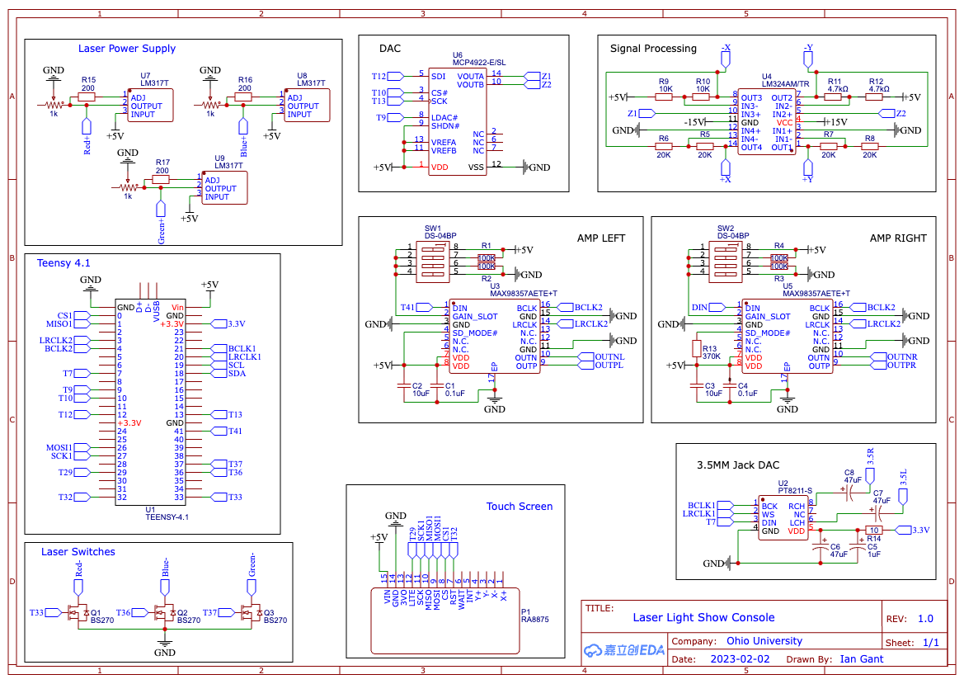

Figure H.1

Our mother board consists of 8 sub-circuits that interface primarily with the Teensy 4.1 microcontroller. The first two sub-circuits that are used for generating the signal sent to the galvo drivers are the DAC and Signal Processing units. The DAC we are using is an MPC4922 12 bit digital to analog converter. This DAC gives us two 12 bit resolution channels that are controlled via SPI. The buffer pin on this chip is what allows us to load both X and Y coordinate information before pushing it to the signal processing unit. Our voltage reference lines are tied to 5v which gives us a 12 bit resolution 0-5v output signal. This results in a 1.2mV resolution on the output. The signal processing unit takes our 0-5v input signal from the DAC and converts it to our differential -5 to 5v output signal that the galvo drivers require. The four channel operational amplifier we are using is the LM324 chip. Each input signal for the X and Y channels are first converted by shifting the voltage by -5v and multiplied by 2 to result in our -5 to 5v range. The second stage is simply an inverting stage that is used to create the differential voltage for both channels.

The second set of circuits used to create our laser projection circuitry are the laser power supplies and laser switches. The power supplies are three LM317 adjustable voltage regulators. These regulator circuits are identical and consist of a resistor and potentiometer that allow us to individually set the voltage used to drive each color laser. These supplies create a forward voltage for the lasers and we use the switches to connect the lasers to ground. The switches are a series of mosfets that are driven by the Teensy 4.1 to turn the lasers on and off.

Our audio consists of three circuits that are used for on-board and external audio. Our on-board audio is generated by two MAX98357 chips that provide 3 watts of power per channel to our 3 watt speakers. The external audio is created by the PJRC low quality sound board which is designed upon the PT8211 16 bit DAC. This output is a line level audio signal that is connected to a standard 3.5mm jack that is mounted to the case. All three of the audio drivers are controlled using I2S via Teensy 4.1.

Finally, our last circuit on the motherboard is the lcd/tft combo driver. This board is responsible for driving the lcd and processing input from the touch digitizer. Both signals are transmitted and received via SPI. The touch screen is our main interface for controlling the console and provides important input and output functionally. The ease of configuring inputs makes the touchscreen a clear choice over more permanent hardware as to allow future software development.

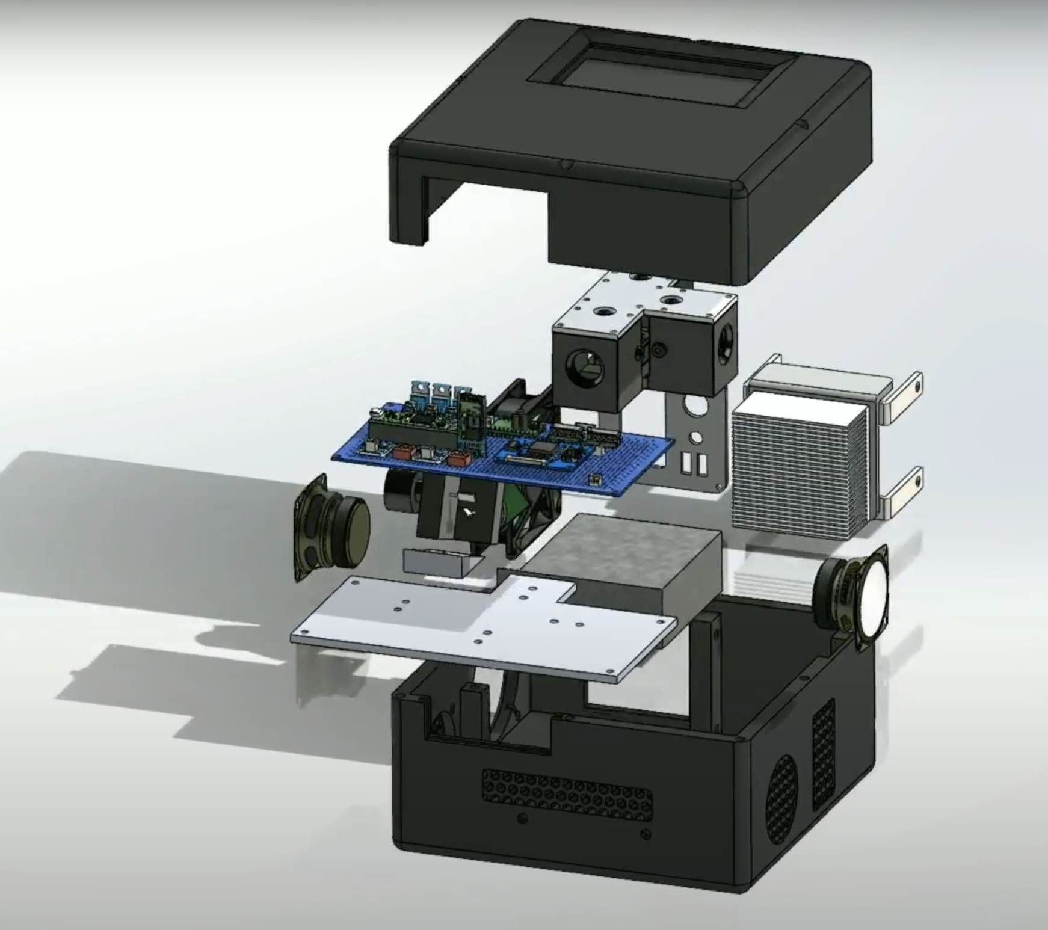

Figure H.2

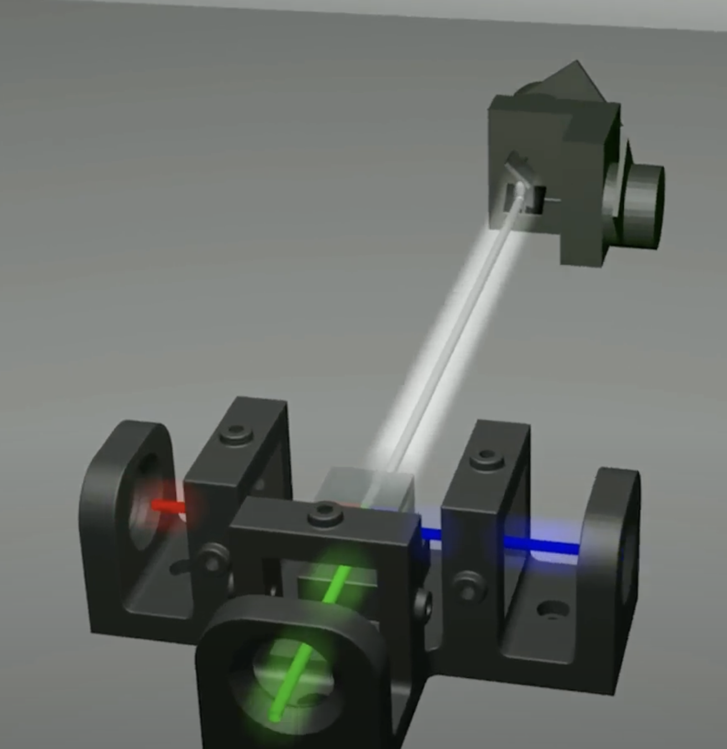

Figure H.3

## While the motherboard is the heart of this project, the case is also equally essential. The mount that holds the lasers in combination with the mounting plate for the galvos is what allows us to mix the red green and blue lasers to make finite color combinations. The lasers are held and positioned by a series of set screws that hold the front of the laser and an O-ring holds the rear. This allows us to move the beams in all directions of a 2D plane. The lasers are positioned at +/- 90 degrees of the central green laser. The beams are combined in the center of the mount via an x-cube or cube of prisms. This light is then projected to the galvo assembly where the X and Y motor can dynamically steer the beams in 4 directions of a 2D plane. This can be seen above in figure H.3

Additional components in figure H.2 that have not yet been mentioned consist of the cooling fan, power supply and driver heatsink. The power supply we used is a +-15v and 5V supply. This provides us with the voltages needed by all systems in a convenient manner. The driver heatsink is important as the mosfets used by the driver board generate a lot of heat. Although the mass of the mirrors is relatively low, the angular acceleration required to generate 20K points per second requires a large amount of power that is dissipated due to the mosfet inefficiencies. Our heatsink is mounted in non-traditional orientation as the air flow of the case is greater than the convection flow. This leads us to the final component, the fan. The fan is a 5v Noctua brand fan that allowed us to easily power it with the 5v rail of the power supply. The fan is configured in a negative case pressure fashion as the air is drawn through vents that pass air through the heatsink and over the power supply and galvo plate. This air is then expelled from the case. A clear piece of polycarbonate is used to pass the laser beams from the case while preventing mass air flow from the resulting hole. This hardware is all packaged densely in a 3D printed outer shell.

Our controllers interface with the console using a simple serial protocol. Each controller features 4 basic inputs via through-hole tactile momentary push buttons. The remaining inputs come from a 2 axis potentiometer style joystick that also features a momentary push button. Each button corresponds with a single bit that is sent in a byte to the console. Each axis of the the joystick sends 10 bits of information to the console. As we are transmitting at 115200 bits/second this means that our 28 bits worth of information are sent in 243 microseconds which is well within our 10ms latency requirement. Each controller is housed in a 3D printed case and interfaces with the console via a standard USB 2.0 connector.

Finally, our I/O panel on the console case features a female microUSB connector that is used for UART connection with the Teensy 4.1. This allows for easy software updates without needing to open the case. Lastly, the 120v input connector has a built-in power switch and fuse. This allows our case to have a grounded and fused power connection to mains voltage which gives us a functional and safe user experience.

## 

## **Software**

### Overview

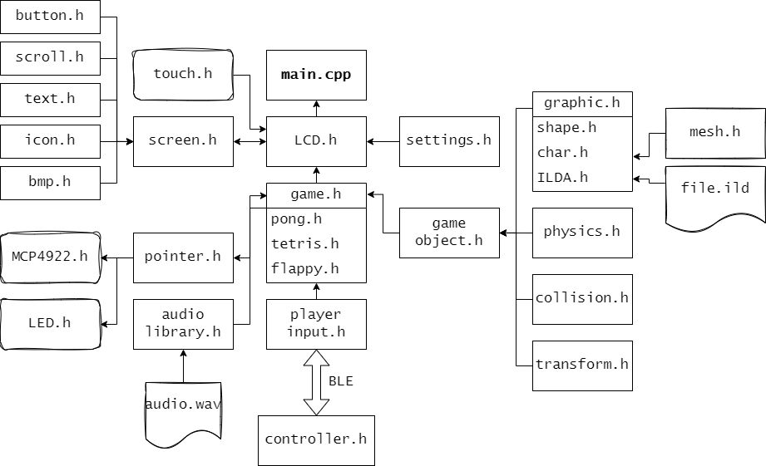

Figure S.1

In order to give you a good understanding of what the software is actually doing, it is important to understand what the purpose of each module is, and how they interact with each other. Understanding this relationship, and why each module exists in the first place, a full picture of the software comes into view.

The software in this project comprises multiple modules that interact with each other to allow for flexible and scalable software development. The main goal of the software is to allow us to interact with the hardware components of the system, while abstracting out some of the complexity. Things like the LEDs and the Galvos are relegated to their own classes that can be interfaced with using functions. These functions are then called by other modules, like the Pong class.

The Pointer.h is a good place to start, as this class is responsible for all movement of the galvos. And thus, the picture being painted by our three lasers

### Pointer.h

The pointer class is a singleton class which is a special type of class in c++. What separates a singleton class from normal classes is that there can only be one instance of this class at a time. The upside to this? We can now reference the pointer.h class from anywhere in the program! This makes sense, as we are only controlling one set of galvos and leds at a time.

The pointer class can move the location of the pointer, as well as change its color.

This is accomplished by two major functions,

**pointTo(Vec 2 pos)**

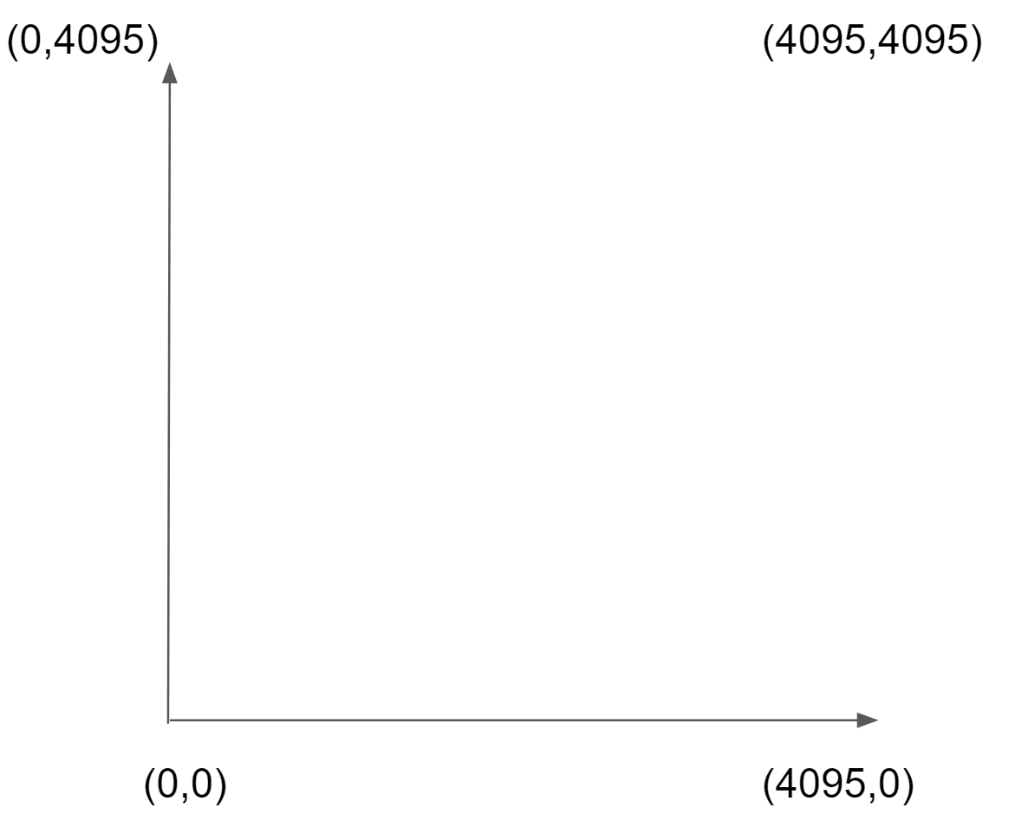

Figure S.2

This function moves the laser to a given position. This position is constrained between 0-4095, and 0-4095 in the X and Y directions respectively. See the figure above for an illustration of how these values map in the physical space.

As you can see from the figure, 0,0 is the bottom left side of the “screen”, while 4095,4095 is the top right side. If we where to move the pointer to the bottom left, turn on the laser, and move it to the top right, we would see a diagonal line.If a point is outside this valid range, its value is clamped to the closest valid value.

**setColor(Color c)**

This function takes an enum that covers all the colors that can be shown by the three LEDs, as well as their combinations.

*enum* Color

{

WHITE,

RED,

BLUE,

GREEN,

CYAN,

YELLOW,

MAGGENTA,

RAINBOW

};

Figure S.3

Rainbow is an extra color used for certain graphics, which will be touched on later.

**SetLed(State s)**

This function decides whether the LED system is on or off.

When it is off, all the LEDs are shut off,

When it is on, it will display the last set color.

### MCP4922.h

This file works in conjunction with pointer.h and is responsible for sending the actual bytecode containing our instructions.

Like we learned before, The MCP4922 is our DAC that takes a 12 bit int, and turns it into a 0-5v signal. MMCP4922.h is a class that is responsible for sending these 12 bit int to the DAC via the SPI bus. When we have a position we want to point the laser to, we create two DAC Packets, one for the X dimension, and one for the Y dimension. Each of these packets are buffered into the DAC, and then the LDAC signal is set to HIGH, allowing the DAC to process these packets at the same time.

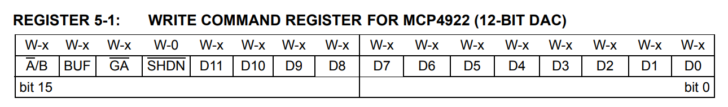

Figure S.4

A 16 bit packet that is sent to the DAC

* A/B - DAC Channel Selection (X or Y Galvo)
* BUF - Is this input data buffered (On by default)
* GA - Gain of the output, (Low by default)
* SHDN - Shutdown the DAC (useless, disabled by default)
* D0-11 - representing the output of the signal, 0-4095 -> 0-5v

### Graphic.h

Graphic.h is the heart and soul of the software library. It is a virtual data class that allows us to print a graphic onto the screen. These graphics include, squares, circles, characters, and ILDA files.

By defining a graphic, and calling graphic.draw(transform t, Color c); We can print that graphic at any position on the screen, aswell as set its desired color. The actual algorithm for printing a graphic depends on the type of graphic.

Since Graphic is a virtual parent class, it doesnt do anything but create a template for the desired functionality we want all graphics to have. The actual implementation of the draw() function will be written in its children

### Shape.h

Child of the graphic.h class

This class draws basic shapes like circles and squares, which one depends on it shape type, which is defined at construction

### Circle

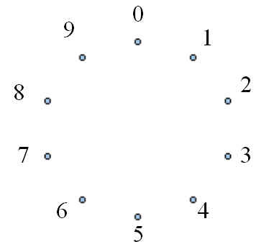

Figure S.5

One of the first algorithms implemented in the project, this algorithm takes a location and a radius and prints a circle at that location

Since we draw shapes with our laser using a collection of points, we need to break up a circle into a number of evenly spaced vertices as seen above. By taking the full 360 degrees of a circle, and partitioning it up into N evenly spaced rotations from 0-360 degrees, we can plug this degree into sin() and cos() to get the position of any given vertice.

Since this would create a unit circle, we then scale all the vertices by our radius, and then add the desired position to each of the vertices,

The end result is a collection of vertices that print a circle given a position and radius.

### Square

The square is simpler than the circle, only containing four points, one for each corner.

Keep in mind that each graphic is locally centered at 0,0. So if you wanted to print a circle in the middle of your screen, you would set its position to WIDTH/2 ,HIGHT/2

Also, since a transform contains both a X scale and Y scale, we can stretch squares and circles in both dimensions.

Since objects can have a rotation, before passing out the final collection of vertices to be printed, we can apply a 4x4 matrix operation to them. Since our vertices are 2D, the z value is simply set to 0.

With this functionality, and the Mat4.h library that will be touched on later, we can allow for rotations along the x,y and z axis.

Mat4 rotationMatrixX = Mat4({{1, 0, 0, 0},

{0, cosX, -sinX, 0},

{0, sinX, cosX, 0},

{0, 0, 0, 1}});

Mat4 rotationMatrixY = Mat4({{cosY, 0, sinY, 0},

{0, 1, 0, 0},

{-sinY, 0, cosY, 0},

{0, 0, 0, 1}});

Mat4 rotationMatrixZ = Mat4({{cosZ, -sinZ, 0, 0},

{sinZ, cosZ, 0, 0},

{0, 0, 1, 0},

{0, 0, 0, 1}});

Figure S.6

### Char.h

Work in a similar manner to Shape.h, but the set of vertices to be drawn are predefined in code… by hand.

So, characters from A-Z + 0-9 + [.,!?] are all added as a collection of vertices, since most letters use the same 9 vertices, all we need to do is define a travel order between the vertices shown at figure 3.

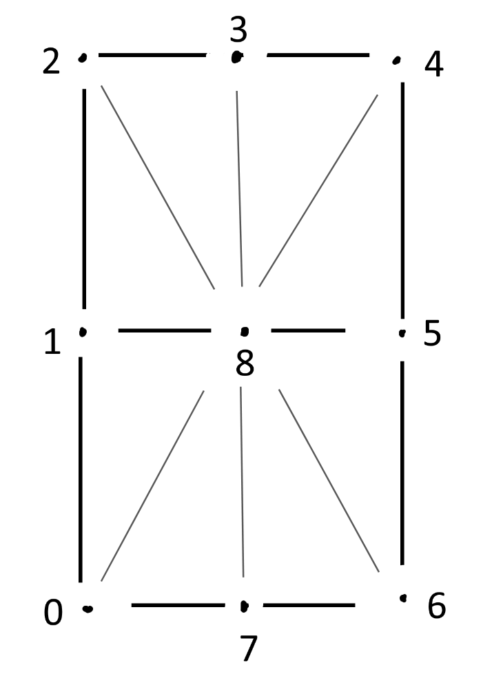

Figure S.7

The draw function for this char graphic simply iterates through this collection of vertices and sends the pointTo commands via the pointer.h.

### ILDA.h

ILDA, or International Laser Display Association, is a standardized file format that contains instructions for a laser projector, specifically, a collection of frames, where each frame is a collection of vertices for a laser to point to. When we draw

In order to harness the power of ilda files, a class is created that can pull the vertex data from certain .ild files.

ILDA files (*.ild) comprise of two byte formats, headers and records, headers and records.

Headers contain information regarding the ILDA file in its entirety

Records contain the individual x,y,z coordinates to move the laser to, along with laser color and intensity

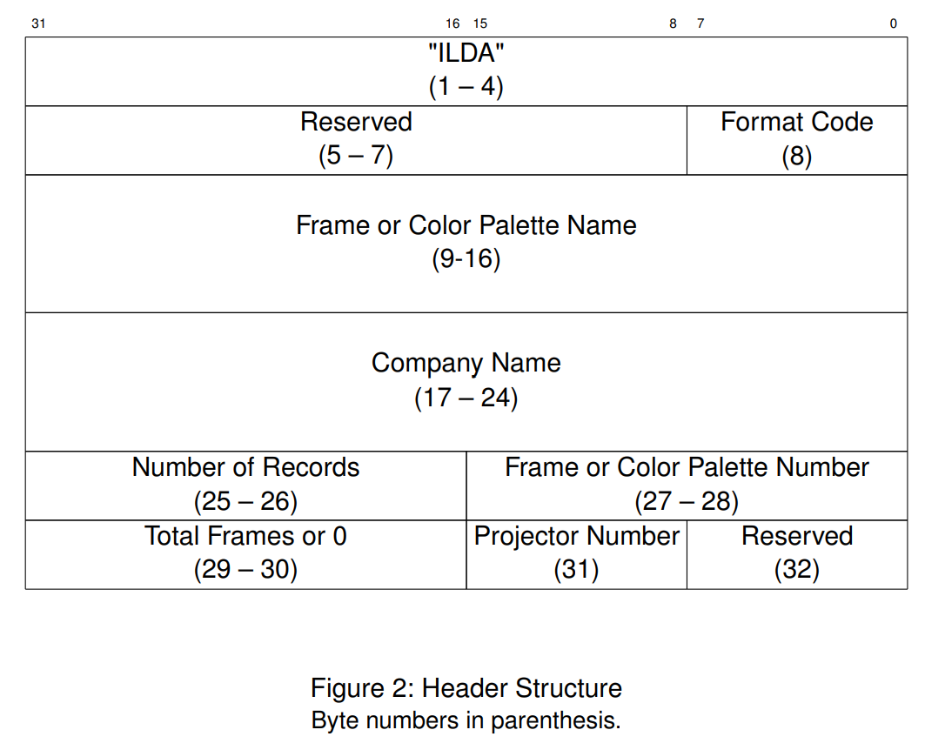

Figure S.8

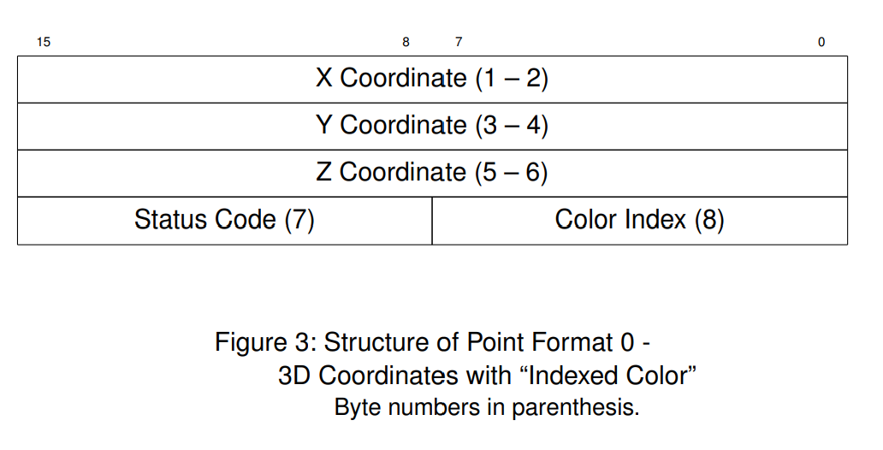

Figure S.9

One thing to note, is that the Teensy 4.1 only has 4098KB of ram, so buffering one of these ILDA files in its entirety is usually impossible. Therefore, we go to our SD card memory and load in data a frame at a time.

This extra time to pull from external memory is negligible compared to the time spent moving the laser.

### Demo.h

If graphics are the ingredients to our cake, then the Demo is the recipe.

In simple terms, demos are predefined scripts that contain a collection of graphics. These demos can be a simple collection of text, to an interactable game like Pong. Anything graphic being printed on the screen will be drawn from a demo.

Any child of a demo class must implement the following functions

* play()
* pause()
* draw()
  + Draws a single frame of the current demo
* update()
* init()
* setSpeed()
  + This is for demos that include a physics word, in which case, this function will allow us to set a speed factor.

There are a couple of classes that can optionally be added to a demo to allow for additional functionality that we will go over now.

### GameObject.h

A gameobject is essentially a wrapper class for our graphics. It allows a graphic to have a transform, velocity, acceleration, collider, mass, and various other attributes. When we see a bouncing ball in our pong game, That ball is represented as a gameobject, rather than a graphic. If we want a graphic, say a circle, to be able to move around, and abide by the laws of physics, than it needs to be a gameobject

### Transform.h

You have heard me mention it before, But a transform is simply a data class that details where an object exists in 2d space. This includes position, rotation, and scale.

### Mat4.h

A class that implements basic 4x4 matrix operations, used by the graphic.h draw() function to project points depending on a rotation, given by a transform object.

### PhysicsWorld.h

A physics world is a self contained world that contains a collection of game objects, Depending on these games objects’ speed, colliders, velocity, ect, it will make various changes to each of the game objects.

For instance, all game objects contained in a physics word will have gravity applied to them.

Likewise, if two circles are inside of each others' colliders, then the physics words will move them appart, until there is no longer a collision.

If two balls move at each other, momentum is conserve as each ball bounced of one another depending on angle of incidence and mass.

### Collider.h

When the physics world wants to detect if there is a collision between any two game objects in the world, it will check if their colliders overlap, and by how much. In order to see if two objects on the screen are colliding, each game object must have a collider.

A collider is an invisible shape around a graphic that allows it to interact with other objects. As of now, due to the complex nature of collision detection, graphics can only have a sphere or a planer collider. Meaning if we are drawing a complex shape like our flappy bird, its collider is actually just a sphere.

The algorithm to detect if two spheres are colliding is as simple as finding out if the sum of the two circles radiuses is greater than the distance between the center of the circles.

The algorithm to detect if a sphere and a plane are colliding is a little more complicated

First, you should define the plane using a normal vector N and a point P that lies on the plane. Then, define the circle using its center point C and its radius r. Next, project the circle onto the plane by computing the dot product between the vector from the plane's point P to the circle's center C and the normal vector N of the plane. This will give you the distance between the center of the circle and the plane. Finally, check if the distance between the center of the circle and the plane is less than or equal to the radius r of the circle. If it is, then the circle and plane are colliding. See the diagram below for a visual explanation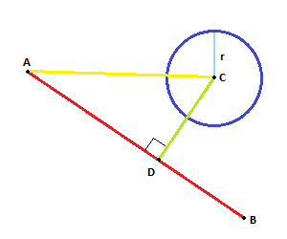

Figure S.10

If the two objects collided, then the depth of the collision, along with the normal of the collision, is return as a struct to our physics world.

### Solver.h

Given a collision, A solver can take a collision between two objects, and modify those two objects depending on a desired effect. For example, What if we had two game objects whos colliders inside one another, We would want the program to push them apart, so this was no longer true. That is exactly what a solvers job is.

Also, What if we had two objects collide, And those objects where moving extremely fast? The desired effect would be that those two objects would bounce off one another.

What was just explained to you were the two solvers that were used in this program, The position solver and the impulse solver.

### Controller.h

0 1 0 1 0 1 0 1

Up Down Left Right Start Menu Encoder Direction

01010101

Encoder Acceleration

Since some of our demos support player input via our two controllers, Its important that we have a class that can facilitate that.

The controller class is simply a class that parses serial input from the controllers. This input contains the state of the four buttons, the rotation of the analog stick, and the button of the analog stick itself. This data is sent over Serial using two bytes as seen above

Each controller works off of a different serial port on the teensy. This allows each player to have a dedicated Serial Bus on the system.

Audio.h

Audio is pretty easy on the teensy4.1 due to the preincluded Audio Library for the teensy 4.1.

By simply loading WAV files onto our microSD card, we can play these file any time during our program.

These files are sent to our Audio Hardware via an I2S signal, This conversion is handled by the library

One thing to note is that only one Audio file can be playing at a time, so there can be no overlapping sound effects.

### LCD Screen

The LCD screen is responsible for user interaction with the unit, It allows someone to

* Menu Navigation
* Settings
* Demo Selection
* Game Selection
* About Page
* And More..

Along with a screen, this LCD supports touch controls.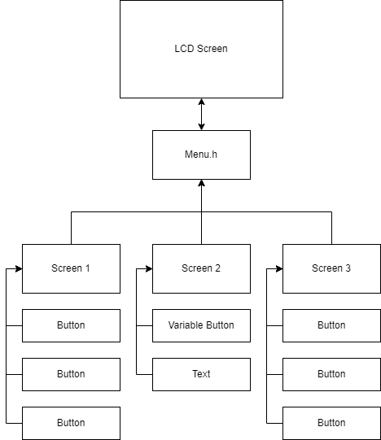

Figure S.11

The LCD works via a controller class called Menu.h. This class is responsible for what being displayed on the actual LCD screen. Depending on the state of menu.h, different screens can be displayed. For example, We might have our main menu screen, and a settings button. When we press that button, we want the program to send a request to change to the settings screen.

In order to do that, we must also implement a way for the user to send commands to the menu class… Buttons.

### Button.h

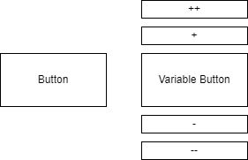

Figure S.12

Buttons are special because they utilize what is called a callback function. In c++, if you have a block of code you want to run when a certain situation arises, say, a button being pressed, the best way to implement that is using a callback function.

When a button is pressed, the code will call that button's specific callback function.

This could do many different things

* Change the current volume
* Pause the current running game
* Change the current screen to a different screen.

The button, like game objects, has a box collider. If a finger press is detected within this box collider,then the button is registered as being pressed. If a button is pressed, its callback function is run, which gives us the ability to traverse the menu with buttons.

Along with buttons, we have Variable buttons. These are an extension of normal buttons that allow us to modify some variable, like a volume slider. See the figure above for an example

### List.h

Lists are a collection of buttons that change in size to fit a certain window.

Say we give the program 10 buttons, and ask it to fit those 10 buttons within half of the screen.

The list does this automatically without any hassle.

This is helpful because the layout of the menus might change, so having a system that automatically lays out the location of buttons save us a lot of time.

### Bitmap.h

Along with basic navigation, we also want the ability to show Images on our LCD. these images are stored in the microSD card in the form of .BMP files.

The algorithm simply parses this bmp files into a set of pixel location and colors. It then sends request to the LCD screen to make the needed changes to those specific pixels. The average time it takes to print a BMP the size of the LCD screen is about 1 second.

### Games

Now that the groundwork is laid out, we can talk about games.

Games are demo files that incorporate a Physics world, and player input.

For example, let's talk about pong.

### Pong

Pong has 5 things that must be displayed

* Left paddle
* Right paddle
* Ball
* Border
* Score

Out of those 5 things, we want the left paddle, right paddle, and the ball to interact in the physics world. So we assign each of those game objects a collider.

Now, all we need to do is define starting conditions for our objects in our init() function

* Speed
* Location
* Size

Since pong is demo file, we need to define a few functions

* play()
* pause()
* draw()
  + Draws a single frame of the current pong world
* update()
  + Steps physics simulations forward by one step, modified by the current game speed
  + Accept player input, and change the velocity of the paddles proportional to the current acceleration of the analog stick.
* init()
  + This function creates the physics word, as well as creating all the game objects that will be in it.
* setSpeed()
  + This is for demos that include a physics word, in which case, this function will allow us to set a speed factor.

In order to detect if a player has scored, we create two new game objects, a left goal and a right goal.

Each of these goals are in our physics world, otherwise we would not be able to detect collisions with the ball. But we don't want these objects to be seen, we just want to know if the ball hits them.

We can disable drawing for game objects by setting their isDrawn = false;

Now that these two big rectangles are in our world, and they are not being drawn with the laser, we need a way to increment the player score if a ball collides with a goal, and reset the ball position.

We do this using our old friend callback functions.

Each game object has a collider, a box that allows it to “touch” other colliders.

If a game object’s collider touches another, we run both colliders callback functions.

So, the callback function for our left goal would look like this.

*auto* player1Score = [&](GameObject2D \**caller*, GameObject2D \**other*)

{

mPlayer1Score++;

Serial.println("PLAYER 1 SCORED");

playFile("goal.WAV");

delay(25);

restartRound();

};

Figure S.13

We increment the score, Play the sound effect, and reset the ball position.

Following this same pattern, creating additional games is very simple, LIke breakout and flappy bird.

### 

# **Management Documentation**

*Document the project from a management point of view. Reference the meeting minutes*

## Schedule

Starting with the Semester, Majority of the meetings took place around 3pm on Mondays, wednesdays and Fridays or 5pm tuesdays and thursdays and lasted an hour to two hours per day where the agenda as well as the tasks for the week were set and followed thoroughly since the beginning of the semester. The work plan mostly followed the times when the whole team was collaborating together and does not account for individual work plan and schedule but the individual work plan and schedule has been added following the chart described below:

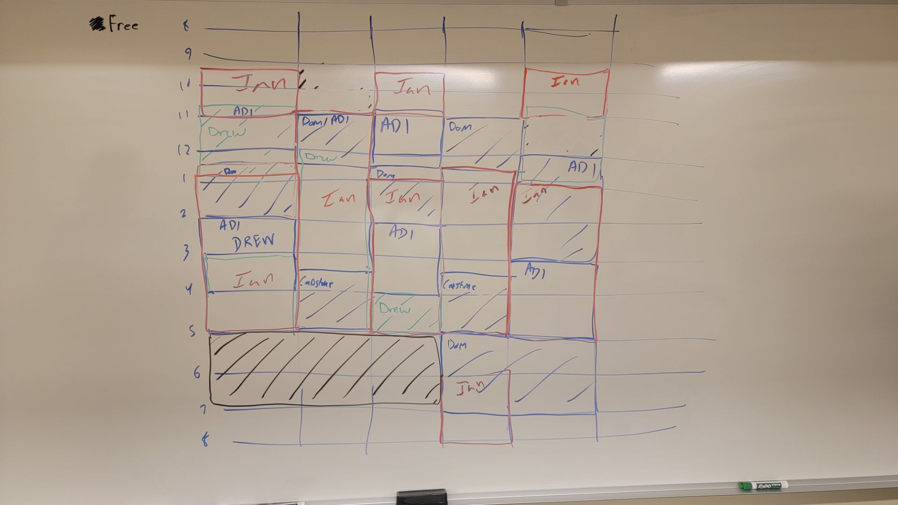Figure MD.1 : Rough Draft for the winter semester schedule

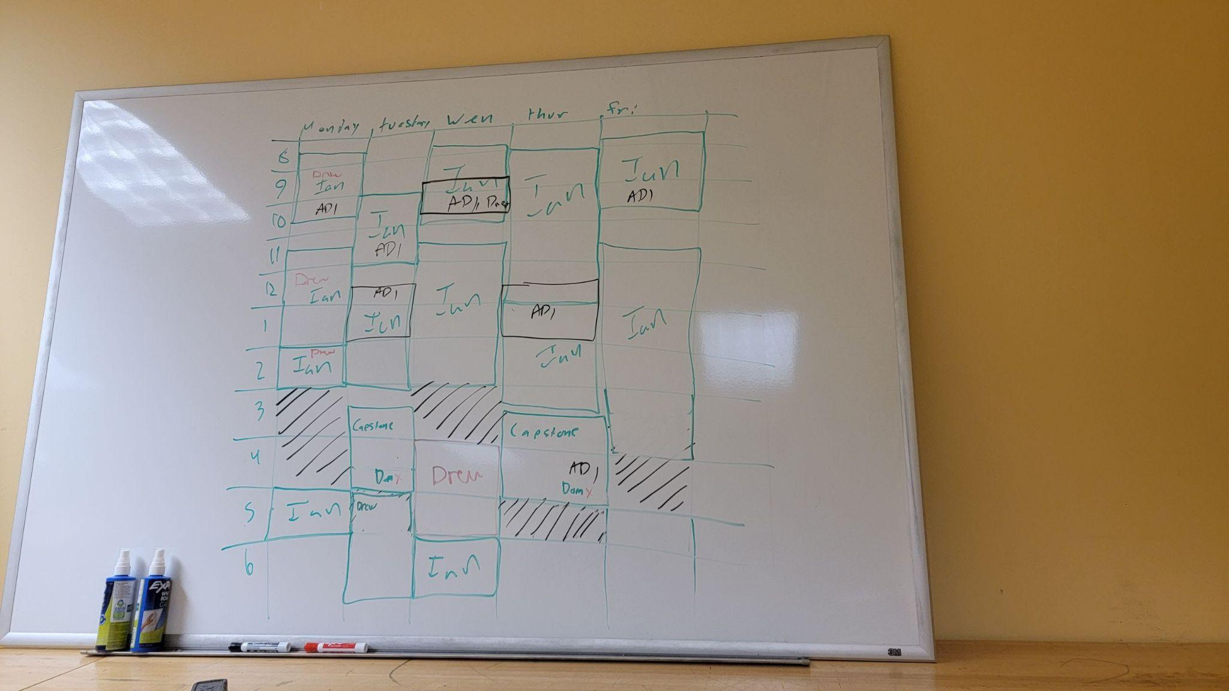

Figure MD.2 : Rough Draft for the spring semester schedule

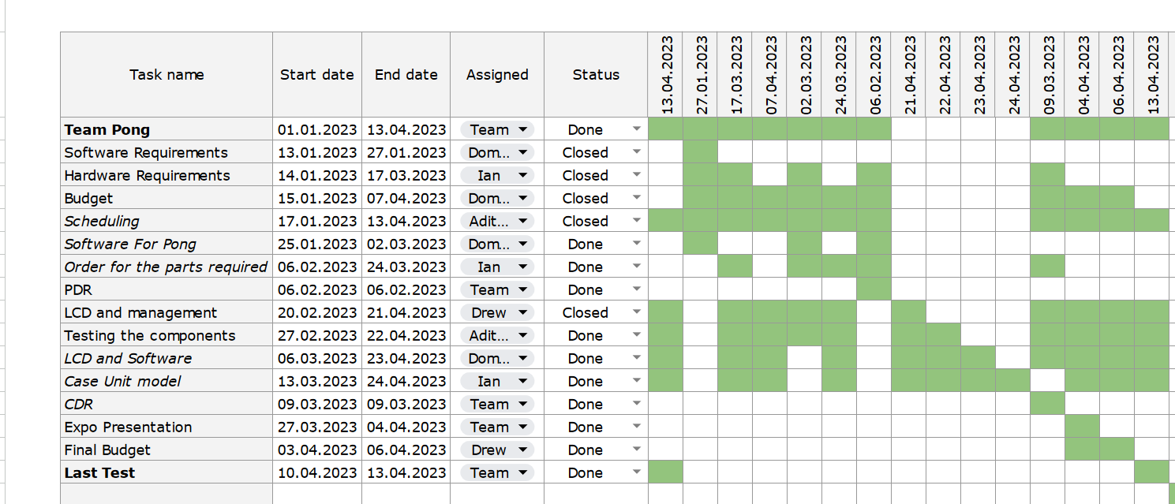

## Major Changes in Schedule since PDR

Our schedule remained the same up until week 6 and that is when the project took a turn from single laser to multiple lasers. Weeks 7, 8 and 9 remained the same with controllers, ILDA files and coding pong. Week 10 the board was remade and the 3D print for the case was started as well as the start of the physics engine. Week 11 was finishing the physics engine and switching from bluetooth controllers to wired ones. Week 12 was finishing the LCD screen and getting the wired controllers to work and then week 13 was finishing the games and integrating the LCD to control the unit up until the day of the expo.

Material Expenditure

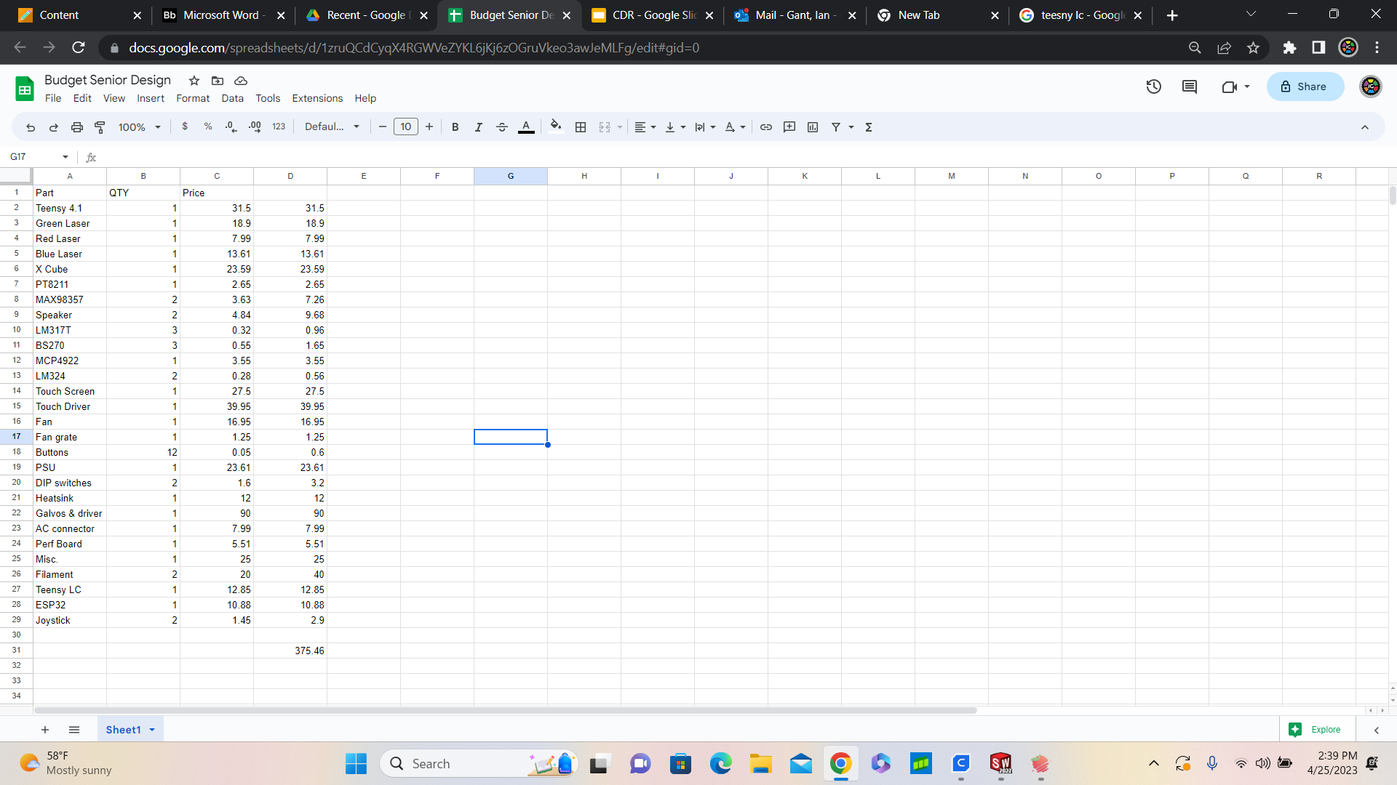

MD.4: Finalized Cost of Materials

Here is a total cost of parts for the final project. Note that this does not include all of the lasers that Dominic burned in his chase for glory, as well as prototype 3d prints. This details what it would cost to remake the final product.

It is important to note here that the team began buying parts out of pocket nearing the end of the project. This was for the decreased shipping time, and the rapid speed of development.

## Labor Cost / Roles

#### Dominic Benintendi

November - April ( 6 months )

20hrs/week = 520 (total hours)

Lead Software Engineer (Glassdoor) $105,000/year = $50.40/hr

$26,208 (total cost) : It's a bit of a stretch.

Responsibilities Included but not limited to

* Software development
* Software documentation
* Implementing hardware changes into software
* The algorithm guy
* Coffee drinker

#### Ian Gant

November - April ( 6 months )

20hrs/week = 520 (total hours)

Lead Hardware Engineer (Glassdoor) $95,000/year = $45.67/hr

$23,750 (total cost) :

Responsibilities Included but not limited to

* Hardware development
* Hardware documentation
* CAD modeling/3D printing

#### Aditya Sahi

November - April ( 6 months)

15 hrs/week = 390 (total hours)

Lead Operations Engineer (Glassdoor) $91,000/year = $43.75/hr

$17,062 (total cost)

Responsibilities included but limited to:

* Troubleshooting
* Collaboration
* Monitoring systems

#### 

#### Andrew Edmonds

November - April ( 6 months)

15 hrs/week = 390 (total hours)

Lead Project Manager Engineer (Glassdoor) $88,000/year = $42.30/hr

$16,497 (total cost)

Responsibilities included but limited to:

* Meeting planning
* Making deadlines
* Tracking meeting minutes

## Total Cost

With the total materials of the project costing $375.46 and the total labor of the project costing $83,517 the total project cost comes out to be $83,892.46. This is a very high cost estimate for the total project.

## Hurdles

### Scheduling

Due to the nature of life and existence, we couldn't all be available at the same time.

Dominic was teaching CS 4100.

Ian was working on Baha

Drew and Adi both had tests and a large number of classes.

This was definitely a challenge we had to overcome. We made our best effort by scheduling time slots where we would all be available. And then tried to meet regularly during those time slots.

Despite our efforts, there were times when we could not all meet, so we had to keep communications open. Snapchat was the main method of communication.

### Locker Space

Our project got pretty large in both complexity, and literal size.

Thanks to the genius thinking of Drew, a quick solution was improvised that will change the game that is vertically aligned storage technology. An additional shelf was added to the locker

## 

## Roles

Ian’s role as being the hardware lead meant handling the hardware materials as well as figuring out which best suited hardware elements to incorporate into the project. His role remained the same throughout the project. Dominic’s role as being the software lead meant writing the code and creating the modules for the project as well as dabbling in some hardware here and there. His role also remained fixed throughout the project. Adi’s role as operations lead meant keeping track of the progress being made and ensuring everything was functioning properly throughout the project as well as helping program the LCD screen for the projector and his role remained the same. Drew’s role as the project manager lead meant making sure deadlines were met while also planning meetings and tracking meeting minutes. He also helped with the start of the LCD programming and his role remained the same for the entirety of the project.

## Intellectual Property

### Software

All software, excluding external software libraries, is IP for the project

### Hardware

All schematics and CAD models created for this project are intellectual property owned by the team.

# **Project Outcome and Team Self-Assessment**

## Project Completion

### Status of Goals, Objectives, Deliverables

(see above for a recap of Goals, Objectives, and Deliverables)

* Goals (100%)
* Objectives(100%)
* Deliverables(100%)
* Constraints(100%)

### High Level Requirements

(See above for a list of requirements)

### Overall Completion

While we did meet the all of the initial high level requirements, during development a few unforeseen issues popped up that we believe are worth noting

* Functionality 80%
  + Functionally was good for what is was, but there were a few features that we didn't get to
    - Tetris game
    - Asteroids Game
    - Additional ILDA files
* Performance 80%
  + There where a few issues that caused a lower than expected Performance score
    - Red and Blue lasers were comparatively dim to green
    - Galvo speed had to be throttled by delays to keep a clear picture, this limited the number of points we could use
* Operation 90%
  + Operation was seamless, baring a few NULL pointer exceptions that would cause the program to crash at the LCD navigation stage.
* Customers need 100%
  + - It is Laser Pong. The average person can summarize exactly what this project is within 3 seconds of seeing it.
* Overall 100%
  + Based on the initial list of requirements, we completed 100% of them, and even went as far as to add additional features and games
  + But, as for what we had envisioned for the project, we came up short in a few areas. The full scope we had in mind captured more than what was recorded in the technical report.

### Future Work

As for future work, There where a few things we wanted to get to that we did not have the time for

* Games
  + Tetris
  + Asteroids
* UI
  + Graphical Buttons
  + Faster BMP loading times
  + General Bug fixes
* Audio
  + Multiple channels to play sounds
* Controllers
  + Wireless connectivity
  + Motion Control
* Software
  + Complete software rewrite conforming to C++ coding standards

## Resource Management

The total project cost of $83,892.46 seems very high for the project. This price is not on the fair end of what was done and I would say that somewhere around the $50,000-60,000 range is more reasonable for the entire project. The results of our project directly reflect the time spent on it with the final product having a few extra features definitely makes it worth the money.

## Engineering standards

* IEC 61508 Functional Safety Standard -
  + The engineering standard for the laser projector may not be considered safety critical for the projector, it may not be necessary to apply the engineering standard for the design and development but designing the projector using good engineering practices, such as the use of safety margins, redundant components, and safety features to prevent hazards and reduce the risk of failure will definitely meet the relevant safety standards
  + By considering the principles and guidelines outlined in IEC 61508, the design and development of the projector was carried out in a structured and systematic manner, with a focus on safety and reliability. This further helped in ensuring that the design of the projector operates safely and reliably under normal operating conditions, and that it can withstand any potential hazards or abnormal operating conditions that may occur.
* IEC 61140 Protection Against Electric Shock
  + IEC 61140 is a global standard that specifies the basic requirements for protection against electric shock for electrical installations and equipment. The standard provides guidance on protective measures and coordination of these measures within an installation, with the aim of ensuring that people and animals are protected against electric shock hazards.
  + During the design of the projector, it was ensured that all live parts are properly insulated and that there is a low-impedance path to earth for any fault current that may occur.
  + The laser output does not exceed the maximum allowable power and that the beam is properly collimated to avoid any potential hazard.
  + All metallic parts that may come into contact with the user are grounded and shielded to avoid any electric shock hazards.
  + Testing the components for safety and ensuring that it is properly maintained to ensure that the protective measures remain effective.
* EC 60529 Protection by Enclosures
  + When building the unit for the projector, the environmental conditions were considered given that the projector will be used in an outdoor environment and the required level of protection was determined using that information
  + The enclosure of the unit is properly sealed to prevent the ingress of dust and water.
  + Since the galvos were generating a lot of heat, ventilation was provided in order to prevent overheating.
* IEC 62680
  + A standard for Universal Serial Bus (USB) interfaces on electronic devices which is a widely used standard for connecting devices to a computer or other electronic device. The IEC 62680 standard specifies the physical dimensions and electrical characteristics of USB 3.1 connectors, as well as the maximum transfer rates and power delivery capabilities of the interface.
  + When designing controllers,it was important to ensure that they are compatible with the USB 3.1 interface specified in IEC 62680 selecting type-A connectors for the controllers and to ensure that the controllers were operating within the power delivery capabilities of the USB interface.
  + Other considerations that were put in place while designing the controllers included ergonomics, usability, and compatibility with the game software being used.
* ISO/IEC 14882:201
  + A standard for the C++ programming language and provides a common set of rules and guidelines for C++ programming.
  + The standard was used to ensure that the C++ code is written to a high standard of quality, including proper syntax, semantics, and requirements.
* The IEEE Standard 802.15.4
  + It was used as a reference for implementing wireless communication protocols.

## Public Impact

### Laser Safety

A major issue we had to consider for the sake of public impact was the strength of our lasers.Above all else, the safety of our users is paramount, therefore, the decision to use low wattage lasers was made.

A side effect of this was that the lasers were extremely dim in well lit areas.Along with this, the red and blue lasers were invisible when compared to the green laser.

See (Meetings notes 10/26/22) for a detailed reasoning for the decision

### Coolness Factor

It may seem a bit strange, but a major factor that we took into mind when making decisions was user enjoyment. We could have used a simple set of buttons to cycle through the demos, but we opted to use a touch screen because we believed it would be more enjoyable to the end customer

Also, the decision to take this project from a simple laser projector, to a full fledged laser pong was also inspired by this same reason. A project that can be interacted with by the user is 10x more enjoyable than a project that cannot.

## Team Dynamics and Communication

Our team health remained very good throughout the project, we were all on the same page and kept up to date by one another constantly. As far as participation and contribution goes, all team members were all hands on deck trying to help as much as possible to complete this project on time. Our team had great communication considering everyone's busy schedules and working on the project at separate times throughout the day. Overall our team worked very well together which led to a successful project in the end.

## Lessons Learned

In the context of a senior design project, one of the things we learned as a team is to START EARLY. By early December, the team had assembled a fully working prototype drawing basic shapes. Even with a working prototype in December, we were still up all night the day before the expo.

We would encourage students who are taking this class to start working with the actual hardware before winter break. This can be harder with certain projects, But things like the LCD screen can be completed completely by themselves.

The full weight of a project isn't experienced until you need to take all the parts you have been working on, and combine them into a finalized product. This state can completely unroot a project back to the design phase.

We don't like to admit it, but we had no idea if the LCD would even interface with the teensy and the LCD until the night before the expo. This was a risk we didn't want to take, and would like to avoid in future projects.

## 

## Individual Contributions

### Ian

My contributions to the project began in early December. In order to begin testing we needed some kind of prototyping platform to support our laser/galvo assembly. This platform was made from medium density fiberboard and had all of our needed modules connected to it via screws and 3D printed parts.

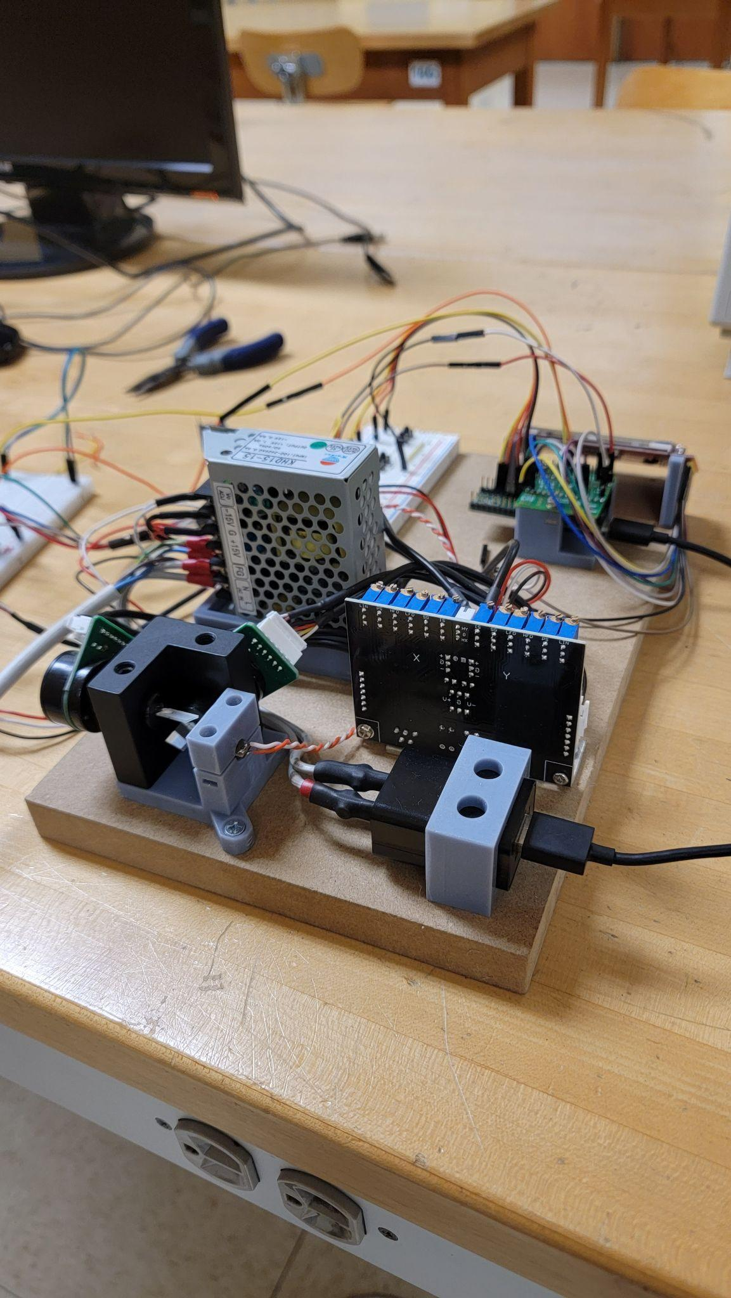

Once this platform was completed, Dominic and I began work on the signal processing unit. This required that I find a suitable DAC as this is arguably the most critical aspect of the project. After we had our prototype fully operational, it was time to move to a more permanent format that could support all the features we wanted to implement.

The next step was implementing the motherboard using a perfboard with through hole connections. This process involved many hours of checking our schematic and soldering components and hookup wire. Once all the connections were made it was time to test all of our hardware for the first time in combination. In order to do this I wrote a series of test programs that are in our GitHub repository. The snippets test all the features including a full galvo range check, lcd/tft test, audio test, laser check and controller connectivity. This led to many hours of CAD modeling for our case and controllers.

The first constraint in modeling a case was that it needed to be within the print size of my printer. This restricted us to a case size of no more than 220 mm3 which made for tight packaging requirements. The next challenging aspect, and possibly the most difficult hurdle, was creating a mount that could hold the three lasers that are required for multi color laser displays. We ended up with 6 different prototypes before the final version that is currently implemented. The main problem with our first designs was that the mounts were not rigid enough to ensure that our alignment was held over time. We found that as the mount was subject to heat from the laser modules and ambient temperature changes, the beams would come out of alignment. To solve this, our final mount uses a very rigid 3D printed mount that has aluminum plates affixed top and bottom in order to keep the mount from moving. Additionally, each laser now has 4 set screws to lock their position, as opposed to our previous two screws per mount. I machined the bottom plate so that it also holds our galvo motor mount and is rigidly affixed to the case above the power supply. The case is also designed so that air flow is directed over and through heat sensitive components for longevity of hardware. Additionally, I machined a mount/heatsink combination for our galvo driver board as it generates the most heat of all the components. The mounts are constructed from steel as the heat conductivity is lower than the aluminum heatsink, this allows the assembly to be bolted directly to the heat sensitive plastic of the case. Due to the positioning of the lcd/tft the motherboard had to be mounted to the top half of the case as the ribbon cable used for connection to the driver board gave us limited mounting locations. The case halves took about 53 hours of printing so I began designing the controllers in the meantime.

The original intention with the controllers was to connect them using classic bluetooth. Unfortunately we found our connection to be unreliable and with not enough time to fix it, we decided to switch to wired serial controllers. Before this switch, I did manage to make a fully functional prototype of the wireless controllers that sported an ESP32 controller. This controller used the onboard bluetooth functionality of the chip and was powered by 4 AAA batteries that were housed in the case. Suspecting that we might need wired controllers, the redesign was as simple as designing and printing a new bottom half of the controller cases to eliminate the batteries. This left us with our final controllers that connect to the console case.

Now that we had all of the required 3D printed components, it was just a matter of assembly. This went smoothly as the whole case was modeled to ensure that we could meet our tight time requirement despite the complexity of the design. All of the fasteners used are screwed into brass heat set inserts so that we didn’t have to worry about stripping the threads of the time valuable cases. Once our hardware was completed it was time to move to software.

While Dominic created the vast majority of our software, once I was done with the hardware I switched gears and helped implement another game within the software Dominic had developed. The game I worked on was the classic breakout which I implemented using the physics engine that allows for easy creation of objects and playing fields.

Overall, this project was extremely fun and rewarding. It has definitely been one of the biggest projects I have had the pleasure to work on. Over winter break I devoted about 30 hours to creating our test platform that paved the way forward. Circuit design and perfboard implementation accounted for about 40% of my efforts. This required about 30 hours a week for 6 weeks. The case designs and 3D printing accounted for the majority of the time as it took about 30 hours a week for 10 weeks. The remaining time was spent helping find parts, machine parts and develop software which accounted for the remaining 4 weeks at 30 hours a week. This brings the grand total to 600 hours over the course of 5 months which was a labor of love.

While there are many aspects of the project that I would like to change or expand upon, I am very happy with our final result. I feel that we did a phenomenal job not just meeting our requirements but also developing a platform that we can further expand upon in the future. Although challenging in many regards, this project was extremely fun and rewarding.

### Dominic

This project was a blast. Never in my life have I poured my all into something for over 6 months. In this section, I want to go over what I did, How I went about doing it, and what I learned along the way.

When I was deciding what project I wanted to work on, there was one criteria I was looking for. It wasn't how much it would forward the good of humanity, It wasn't what would look best on a resume, and it certainly wasn't based on any previous skill. My one thought when I saw laser light show was, “This is going to be sick”

As someone who has already been to a student expo before, I knew what the judges would be looking for. Something fresh, something they hadn't seen before, Something interactive, flashy, abnormal. After seeing the same project year after year, the laser light show was perfect.

My inspiration, if you can call it that, struck the moment Ian brought in our first prototype into the lab. It was around Early December. Back then it was just an LCD screen with a basic implementation of pong, using four buttons. But when we got those galvos in the mail, the floodgates opened.

The first step was figuring out how to get the teensy to output signals to control the DAC. Back then we were using the old I2C DAC, which only had one channel. Due to this, the first thing I could do was get a horizontal line moving from the left side of the screen, to the right. Easier said than done. This required me to set up a couple of op amps that would increase the gain by 2x, lower the range by 5v so that the signal was centered around 0v. Since the signal accepted by the galvo driver was a differential signal, I needed to feed it two voltages, terminals A and B. Depending on the difference between these two values, The galvo would go from one extreme to the next.

If A was -5 and B was 5v, then the galvo would point the laser to the left, if A was 5v and B was -5v, then the galvo would point to the right.

With this in place, I had the beginnings of our project, A single galvo that can access the full range of its movement given a 12 bit int 0-4095. I slapped a sin() function on the value and had an oscillating point on the horizontal axis.

Christmas came, literally and figuratively, The second dac arrived. Within about 30 minutes, I copied my design over to the second dac, and hooked it up to the other galvo. I change the sin() to a cos() on the Y axis and BAM! a circle. This was a huge milestone, but there was a problem.

Up until now I have been writing all my code in the Arduino IDE. This was a problem because my program was becoming complex. I wanted to start abstracting out these basic shapes into different classes and the Arduino IDE wasn't built to handle anything bigger than one file.

I'll skip the theatrics, PlatformIO was great , I would recommend any future capstone student to use PlatformIO instead of the Arduino IDE ( see here for more detail). It is easier to use, follows standardized c++ coding law, supports a large number of libraries, and has a sleek UI.

After this point, I began rewriting what I have created thus far into classes to allow for ample scalability. This was the birth of the pointer.h and shape.h class. From here it was a steam roll, Characters, Sentences, Squares, Circles, Grids. I was posting my progress on Snapchat and got a few good pictures of what results looked like early on.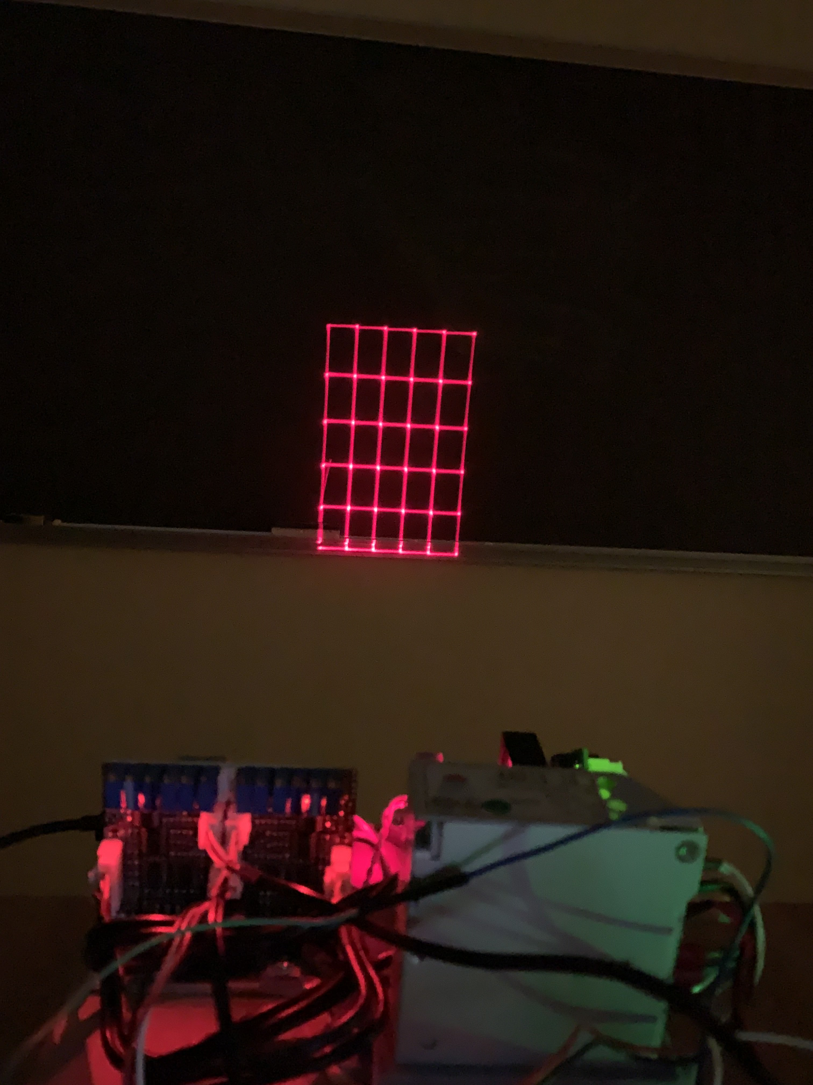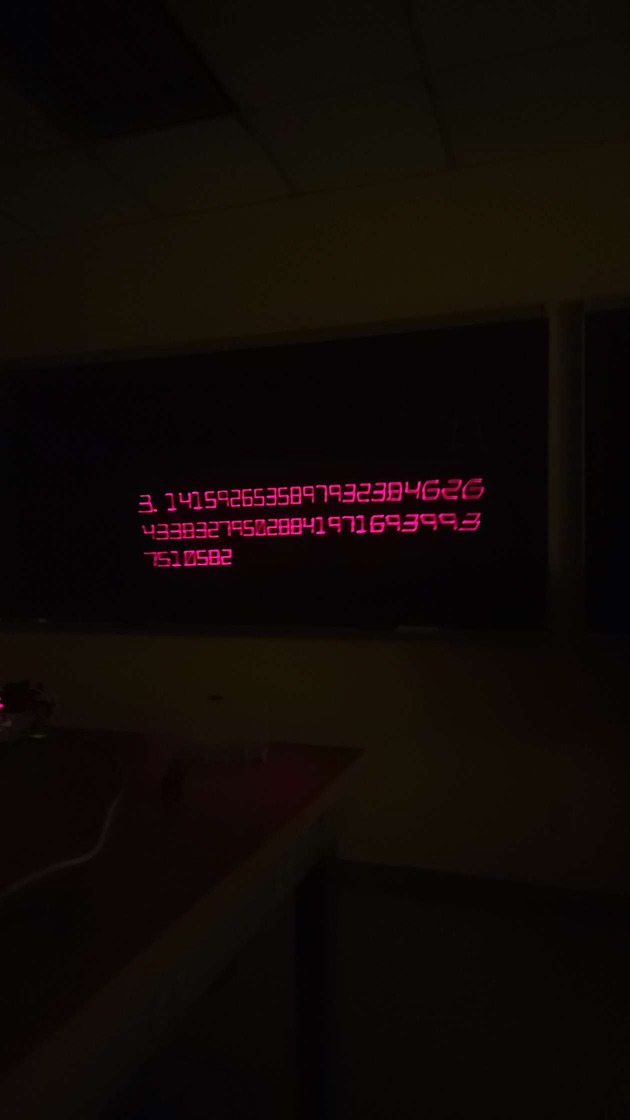

There was a problem, it was already late february and the expo was quickly approaching. And that deadline would approach rather quickly. We needed to delegate what would be left of the project.

We assigned Adi and Drew to the LCD, and Ian to the controllers. Along with this, we made the decision to support three colors, red green blue. These colors were combined using an Xcube. With this I would be able to focus entirely on the actual goal of the project, the games.

I cleaned up the code and got to work on the actual game portion. Since I had in the back of my mind the idea of multiple games, I wanted to create a physics engine. This was an endeavor on its own, and if I had the time, I would have implemented full convex hull collision.

With this I also started refactoring how objects were being drawn to allow for abstraction in the form of the graphic.h class. The idea of polymorphism as a C++ concept wasn't well known to me, but I had to learn some time.

Fast Forward to the middle of march. The atmosphere was intense. Sweat rolled down my forehead as we ripped apart the project like a surgeon. Me and Ian made the decision to completely redo the circuit board, which halted all progress on the main unit.

In the end, the board worked perfectly with a few fixes, and it looked gorgeous.

Time flew, and the expo was fast approaching. The controllers were nearing a state of completion, and the Pong game was finished. The problem was that the LCD screen still wasn't in a working state.

I was currently extremely busy with the main unit, but I had the time when Ian mysteriously took the main unit for a week. What he was plotting I couldn't have possibly known.

I spent the next week building the lcd code from the ground up; Menus screens buttons, Only to see what Ian had been working on. A fully 3d printed case.

It was immaculate, and it worked on the first try. I couldn't believe that our scrap of electronic heap was nearing completion.

Tick tock, the expo was only a week away.

During this time, me and Ian barely slept a wink. We would go over to his house and work on the project until the late hours of the night, fueled only by coffee and an intense focus that could be confused for borderline insanity. I don't think I could have done this part alone.

I was tasked with getting the lcd screen working with the code we had written thus far, it was the final step in a 6 month battle. Ian had already gotten the hardware to a state of satisfaction, I just needed to connect the wires… figuratively.

It worked. It was good, really good. Having all these different parts finally coalesce into a symbol of our months of hard work was cathartic.

The night before the expo, me and Ian stayed up finalizing our product, I created Flappy Bird and he created Breakout. Along with a few hundred bug fixes.

The expo finally came and I was exhausted, my reflection looked back at me with baggy eyes, but it was worth it.

First place, I can't overstate how much that little 30 cent piece of ribbon felt in my hands. I have worked so hard on this project, and to be recognized for that work made everything seem fair. I sacrificed a lot of weekends to be at this point, and the cost was well worth the reward.

Overall, This project was somewhat life changing. It gave a visual form to our hard work and effort. I struggle to find something that brings the same level of fulfillment in my everyday life.

Thank you.

As for time spent, I lost track a while ago, But i would say that 20 hrs/week seems close. There were weeks, Like when Ian was working on the case, Where I really didn't have the ability to do a whole lot. There were also weeks, like the week before the expo, where I easily clocked in around 40 hours working on the project.

I'm not going to lie, it was like a full time job. And there were days where I wanted to go home, exhausted. But I kept at it because it would look sick at the expo.

### Drew

As the lead of project management for the laser light show project, I was in charge of scheduling meetings and figuring out a weekly schedule to get together and work as a group on the project. With everyone having full and busy schedules we had to come up with a regular work schedule to get the project done in time for the senior expo. Once we had a somewhat regular schedule in place, I then kept track of the progress we were making and made sure that we would be on track to meet our several deadlines throughout the semester.

Not only were we tasked with creating and designing this project but along the way we had to document and present our progress through papers and power points. Everytime we had a deadline to meet I made sure that our work had exactly what was expected and met all the criteria on the guidelines. Making sure we were meeting deadlines was just as important as building the project since the class is based on both parts of the entire process.

I also kept track of the budget and how much we were spending in parts to make sure we were under that $500 budget. Luckily our project wasn’t too expensive since we used most of our early prototype parts in the final design which allowed for more room in the budget. Towards the end of the project we had to buy some parts out of our own pockets due to shipping times but in the end we are getting that money back for winning first place which definitely helps.

In the early prototype stages of our project I assisted Dom on setting up the initial signal processing circuit which allowed for some early hands-on hardware work. With Ian being our advanced hardware guy I did not touch too much of the hardware moving on but I always offered a helping hand if it were needed. When we first got the LCD I was in charge of getting it all set up with the driver board and put on a breadboard to allow testing. I got the LCD screen set up initially and started to run test code to ensure that it was ready to get implemented into the design. The next step was to start building a user interface so that the user could control the unit via the LCD screen. This started out as Adi’s and I’s task and we spent quite some time on building the menu and with the expo getting closer and closer Dominic took it from there and integrated it into the code that he had written. Since we used bmp files for our background and caution icon I was in charge of converting them and uploading them onto the SD card of the teensy. This took a few iterations due to them not having the correct format and not looking how we wanted them to on the LCD screen.

I am a very organized person and every time I opened our locker it looked like a tornado had hit it and I could never find anything without digging through everything in the locker which drove me nuts. It is a very minor part of this project but I organized our locker and separated our parts into certain areas making it easier to grab and find things. I also later invested in a nice adjustable locker shelf which will be donated to the senior design lab and it helped out so much with keeping our locker organized and clean. It is a very small thing but it really helped with getting in and out of the locker.

I am very grateful to be a part of such a great team and everyone in this team impressed me on how much time and effort they put into making the project happen. It was always so rewarding to hit a certain milestone and see our hard work pay off not only on paper but in live demonstrations. The switch from a single laser color to three multiple color lasers was the best thing we could have done and we were so happy when we pulled it off.

I am proud of the role I played in this project and I think it was very important to make sure we were always on track and completing the objectives we had. It was great being able to present our project to so many people and seeing their reactions. It definitely was worth all the time and effort seeing how everyone enjoyed playing pong and watching the ILDA animations. For the time spent on this project I came up with an estimation of 15 hours a week even though there were weeks where it was more and less this was a good average with a total of 390 hours in the span of 6 months.

### Adi

As the lead in operations for our capstone project, I put in a significant amount of time each week to ensure that our laser light projector was built from scratch and functioning properly. Specifically, I was responsible for working with the LCD screen to control the laser light projector and ensure that it was fully operational. I spent countless hours researching and analyzing trade studies to determine which components would be the best fit for our project, taking into account factors such as cost, functionality, and reliability.

One of the key challenges that we faced during the project was ensuring that all of the components were integrated seamlessly and working together as a cohesive system. This required a great deal of attention to detail and careful planning, as even a small mistake or oversight could have serious implications for the functionality of the projector. However, through a combination of careful planning and diligent testing, we were able to successfully integrate all of the components and create a projector that was not only functional, but also visually stunning.

Throughout the project, I was also responsible for logging meeting minutes and ensuring that everyone on the team was up to date with the latest developments and progress. This required strong organizational skills and the ability to work well under pressure, as there were often tight deadlines that needed to be met in order to keep the project on track.

In addition to my role as the lead in operations, I also worked closely with the rest of the team to ensure that we were all on the same page and working towards a common goal. This involved regular meetings and discussions to ensure that everyone was up to date with the latest developments and progress, as well as frequent communication to address any issues or concerns that arose throughout the project.

One of the most challenging aspects of the project was coordinating the efforts of the different team members, each of whom had their own areas of expertise and responsibilities. However, through effective communication and a strong sense of teamwork, we were able to overcome these challenges and work together to create a truly impressive final product.

Another key factor in the success of the project was the extensive research that we conducted in order to determine the best components and materials to use. This involved analyzing a wide range of trade studies, as well as conducting our own experiments and testing to ensure that the components we chose were both reliable and effective. We also took into account factors such as cost, availability, and ease of use, in order to create a projector that was not only functional but also practical and accessible.

Throughout the project, I was constantly impressed by the dedication and hard work of my teammates. From the early planning stages to the final assembly and testing, everyone on the team contributed their skills and expertise to help create a project that we could all be proud of.

One of the most rewarding aspects of the project was seeing the final product come to life. After months of hard work and dedication, we were able to create a laser light projector that was not only functional, but also aesthetically pleasing and visually striking. Seeing the reactions of our classmates and professors when we demonstrated the projector was truly gratifying, and it was a testament to the hard work and dedication of everyone on the team.

Looking back on the project, I am proud of the role that I played in helping to bring it to fruition. From researching and analyzing trade studies, to working with the LCD screen to control the laser light projector, to logging meeting minutes and keeping everyone up to date, I was able to make a meaningful contribution to the success of the project.

As for the time spent, keeping track of it seemed difficult given the hectic schedule we all were facing during the points in the semester but ideally I would count around 15 hrs a week including the meeting as well as working on the project as well as keeping track of the progress and the meetings.

# 

# 

# 

# References

# Meeting Notes

* 10/26/22 - Laser Safety

[**https://stackoverflow.com/questions/1073336/circle-line-segment-collision-detection-algorithm**](https://stackoverflow.com/questions/1073336/circle-line-segment-collision-detection-algorithm)

[https://ww1.microchip.com/downloads/en/devicedoc/atmel-7766-8-bit-avr-atmega16u4-32u4_datasheet.pdf\](https://ww1.microchip.com/downloads/en/devicedoc/atmel-7766-8-bit-avr-atmega16u4-32u4_datasheet.pdf%5C)

<https://www.ti.com/lit/ds/symlink/lm317.pdf>

<https://ww1.microchip.com/downloads/en/devicedoc/22250a.pdf>

<https://www.analog.com/media/en/technical-documentation/data-sheets/MAX98357A-MAX98357B.pdf>

<https://www.ti.com/lit/ds/snosc16d/snosc16d.pdf>

<https://www.pjrc.com/store/pt8211.pdf>

<https://cdn-shop.adafruit.com/datasheets/RA8875_DS_V19_Eng.pdf>

<https://www.onsemi.com/pdf/datasheet/bs270-d.pdf>

# 

# Appendix

**EE4953 – EE/CpE Capstone – Laser Show Team – Meeting Minutes**

**Location:** Stocker Center Rm 326 (EECS Essman Conference Room)

**Date:** 19 October 2022

**Time:** 17:00 – 18:00 ET

**Attendance:** Dominic Benintendi, Drew Edmonds, Ian Gant, Aditya Sahi : Dan Allwine

**Not Attending**: Tianyi Cai (Absent due to prior commitment)

**Discussion:**

1. General introductions and overview

Everyone in attendance was already acquainted, so no introductions were needed.

Dan discussed the general purpose of the meetings, including:

* The expectation that the student team members would be responsible for managing the meetings going forward. This includes running the meeting and recording meeting minutes.
* There is significant flexibility granted to the team to manage things as they see fit – as long as the process is rational and consistent. From time to time, each team member may be asked to run all/part of a meeting in order to gain experience.

Dan went on to discuss the process and need for meeting minutes, which includes:

* Allowing those not in attendance to understand all major actions taken by the team and to have a general grasp of 80-90% of what transpired. By necessity, minor details will be left out.
* Another highly important element of the minutes are action items, whereby each project stakeholder (team member, advisor, etc.) may be assigned specific tasks if/as needed along with specific deadlines. This represents a major tool for maintaining accountability and keeping the project on track.
* Minutes should also capture the results of risk assessment and mitigation planning activities.
* The minutes should be circulated to the attendees for comment in a timely fashion after the meeting, and they should be ratified during the subsequent meeting (pending any needed edits). Once ratified, the minutes become “law” for the team.

Finally, Dan indicated that the team must develop an effective mechanism for communication, file sharing, administrative organization, etc. At a future point, the team shall be required to discuss this.

1. Round-table discussion:

What interested you in the project? What is envisioned, and what are suggested features? The team has some latitude in establishing the specific nature/scope of the project.

Individual comments:

* Ian: Interested in persistence of vision and use of MEMS technologies. A related concept could be fabrication of a rotating LED display.
* Dominic: Interested in concepts regarding how to harvest/encode image data for display. Vector graphics is an obvious mechanism, but there are others.
* Aditya: Interested in laser technology and the software required to manage the images.
* Drew: Interested in laser technology.
* Dan: Changing the topic from laser projection to a rotating LED display is permitted. The team is allowed to decide this (first action item).

1. Other discussion: The 5-6pm meeting time on Thursdays and Fridays is no longer possible.
2. Action Items:

**Who**: Entire Team **Deadline**: Next Meeting (Sooner if possible)

Conduct additional discussion to establish the overall scope of the project. In particular, this includes whether the project focus will change from laser projection to a rotating LED display. This could involve additional interaction with Dan and/or Tianyi, prior to the next meeting. This will allow project inception and design requirements to be firmly established.

1. Next Meeting: **17:00 ET – Wed, 26 Oct 2022 (EECS Conference Room, if available)**

**Location:** ARC 219

**Date:** 24 October 2022

**Time:** 17:00 – 18:00 ET

**Attendance:** Dominic Benintendi, Drew Edmonds, Ian Gant, Aditya Sahi

**Not Attending**: Dan Allwine, Tianyi Cai

**Discussion:**

1. Project Scope:

In accordance with the last meeting's action items, we discussed what route we would like to continue with and decided upon the original laser projection project. We came to this decision based upon the group's majority interest in laser technology. Having decided this, we continued the discussion by talking about adding additional features to the still image projection such as a construction wall plotter and/or level.

1. Meeting Platform:

We decided that our primary mode of communication will be through Discord as decided by majority vote. In addition to this, Microsoft Teams will be used if necessary for virtual meetings with Dan and Tianyi.

1. File Sharing:

Dominic created a team google drive that we can use to store and share any necessary files such as meeting minutes, source code, schematics and so on.

1. Action Items:

In an attempt to be proactive we would like to begin by doing some preliminary research by the next meeting. This research will not be of extreme detail but instead, will lead us in the right direction for identifying constraints and deliverables.

* Ian: Driving mechanism for mirror (2 axis freedom)
* Aditya: Laser options and driving circuits
* Dominic: Microcontroller and motor drive
* Drew: General safety and rapid eye tracking

1. Next Meeting: **17:00 ET – Wed, 26 Oct 2022 (EECS Conference Room, if available)**

**Location:** Online

**Date:** 26 October 2022

**Time:** 17:00 – 18:00 ET

**Attendance:** Dominic Benintendi, Drew Edmonds, Ian Gant, Aditya Sahi, Dan Allwine

**Not Attending**: Tianyi Cai

**Discussion:**

1. Project Scope:

In accordance with the last meeting's action items, each member did preliminary research on a specific topic they were assigned, and talked about it in front of the group

* 1. Ian: Driving mechanism for mirror (2 axis freedom)
     1. Spoke about a system including two galvanized motors
  2. Aditya: Laser options and driving circuits
     1. Offered a research paper on the topic of laser options and laser safety
  3. Dominic: Microcontroller and motor drive
     1. Talked about microcontroller and project scope
     2. 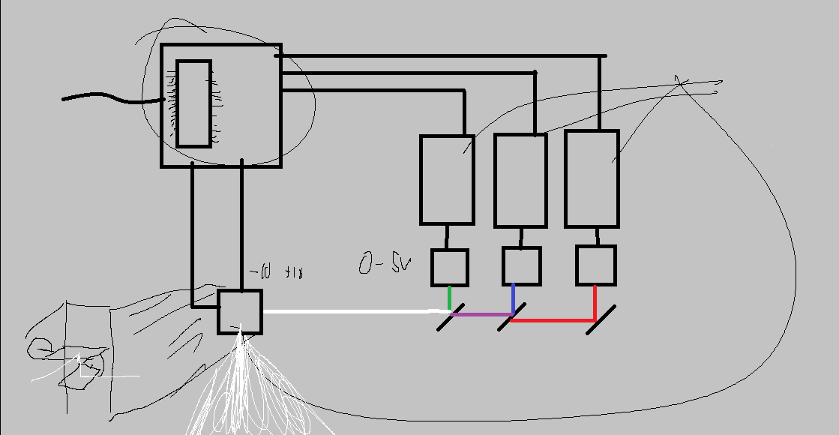
  4. Drew: General safety and rapid eye tracking
     1. Talked about the different classes of lasers

1. Safety discussion :

Dan made is clear that we should sacrifice project performance in the name of safety in the future, ergo, we should work with low wattage lasers if possible

1. Possible Scope

After confirming our desire to go down the laser projection route, We looked at several different avenues for the project to go.

* 1. How many colors?
  2. How many lasers?
  3. Moving images?
  4. Possible implementation with asteroids game

1. Budget
   1. Team will be given 500$ for our final version of the project
   2. Intermittent designs will not be counted towards the final projection
   3. We can also include the use of our own parts, but they cant be taken back mid development
2. Action Items:

By next monday, we need to do the following

* Finalize Major project scope, Where do we want to go with this?
* Everyone must give their ideas on the discord

1. Next Meeting: **17:00 ET – Tue, 1 Nov 2022 (Somewhere in ARC, if available)**

**Location:** Arc 216

**Date:** 01 November 2022

**Time:** 14:00 – 15:00 ET

**Attendance:** Dominic Benintendi, Drew Edmonds, Ian Gant, Aditya Sahi

**Not Attending**: Tianyi Cai, Dan Allwine

**Discussion:**

1. Team building discussion:
   1. Dominic - Personality test results were INTJ which is Introvert (31%) iNtuitive (34%) Thinking(22%) Judging (3%)

Pros:

* Likes to plan and have structure.
* Reliable and loyal.

Cons:

* + - * Might not value others opinions as much as your own.
      * Highly independent.
  1. Drew - Personality test results were ESTJ which is Extravert (34%) Sensing (9%) Thinking(25%) Judging (34%)

Pros:

* Confident and logical.
* Very structured and goal oriented.

Cons:

* Stubborn and hard headed.
  + - * insensitive.
  1. Ian - Personality test results were INTJ which is Introvert (9%) iNtuitive (19%) Thinking(56%) Judging (9%)

Pros:

* Logical and rational based decisions.
* Innovative and curious.

Cons:

* + - * Perfectionism.
      * Stubbornness.
  1. Adi - Personality test results were ENFJ which is Extravert (44%) iNtuitive (12%) Feeling (9%) Judging (16%)

Pros:

* Fun.
* Reliable.

Cons:

* + - * Condescending.
      * Selfless.

1. The introverts in the group will have their focus on communicating with the group whereas the extroverts can focus on communicating with others outside of the group. With this we have the perfect balance of communication with both interior and exterior persons. The intuitive people will be able to see the bigger picture where the sensing will see the present and break things down into tasks.
2. Possible personality conflicts could occur with the large divide between Extroverts and Introverts. While Introverts might be more privy to isolate and focus on the projects, Extraverts might want to communicate with other groups. This is merely an example, but this divide could cause possible issues in the future.
   1. Another possible conflict is due to priority of values, some students might put major focus on academics, while some students focus on job opportunities and networking.
3. As a group, our team's ideas and goals for the future are seeming to align. Though we all have different ideas on how we are going to reach our goals, We all understand where we need to go. This abundance of different viewpoints, with an emphasis on respecting others views on the situation, will surely bear fruit as time progresses
4. **Motto:** Innovation that lights

Action Items:

By Thursday, we need to do the following

* Look for possible laser kits to familiarize and experiment with.
* Identify major subsystems.
* Where can we experiment? Senior lab?

Next Meeting: **17:00 ET – Th, 3 Nov 2022 (Somewhere in ARC, if available)**

**Location:** Stocker Center Rm 326 (EECS Essman Conference Room)

**Date:** 03 November 2022

**Time:** 16:10 – 16:50 ET

**Attendance:** Dominic Benintendi, Drew Edmonds, Ian Gant, Aditya Sahi, Dan Allwine

**Not Attending**: Tianyi Cai

**Discussion:**

The team and Dan discussed using galvo motors over stepper motors as well as using colored lasers, if there are any troubles with colored lasers then Dan would prefer a single color over multiple. The team will carry out experimentation in the senior capstone lab and we went over general lab rules. We also talked about how there will be a few hundred dollars allocated to early stage design for experimentation. The project goal is to project an image/animation onto a wall. The team needs to decide if we want to make a game or stick with just images/animation.

Action Items:

* Determine what route we want to take for project images/animations or game
* Talk about project inception

Next Meeting: **TBD**

**Location:** ARC 214

**Date:** 8 November 2022

**Time:** 15:00 – 16:00 ET

**Attendance:** Dominic Benintendi, Drew Edmonds, Ian Gant, Aditya Sahi

**Discussion:**

1. **Project Direction:**

| **Concrete** | **Stretch/possibility** |
| --- | --- |
| **Project image/animation** | **Game engine** |
| **Project multiple entities** | **Three colors:**  **TTL 16**  **PWM 16,000** |
| **Supports single color** | **Controller support** |
| **2 degrees of movement(X,Y)** | **Audio/ music support** |
| **Chassis** |  |

1. **Laser Kit findings:**

* Buy galvos / drivers / mirrors
* Microcontroller (Teensy 4.1)
* lasers( good for now)
* Power supply
* Galvo clamp / bracket

1. Decision regarding the project.

**Ian : game**

**Drew: No game**

**Dominic: undecided**

**Aditya: game**

1. **Approach both of the ideas, making sure requirements are met for at least one of them**

**Location:** Stocker 326 (EECS Essman Conference Room)

**Date:** 10 November 2022

**Time:** 16:30 – 17:30 ET

**Attendance:** Dominic Benintendi, Drew Edmonds, Ian Gant, Aditya Sahi, Dan Allwine, Tianyi Cai

**Not Attending**:

**Discussion:**

1. Decided to go with pong implementation
   1. Controller ideas
      1. Wireless
      2. Rotary encoder for greater control of paddle
   2. Laser color
      1. Green as it will show up best
   3. Stretch goals
      1. Hand gesture paddle control
      2. Multi color game play
      3. Audio
2. Discussed A01 and came up with the general definitions
   1. Need statement: a system that can display a game of pong using laser projection graphics.
   2. Goal(s): Display 2 player game of pong using laser projection and 2 wireless controllers
   3. Stakeholder: Who is involved and what are they doing
   4. Constraints: Money, time, safety
   5. Deliverable: Working prototype, design report, design documentation, source code, user guide
   6. Con-op: Not design or design process, describe our envision of the product ~page

Action items: Make list of item for Dan to purchase

Next Meeting: **17:00 ET – M, 14 Nov 2022 (Online-Discord)**

**Location:** Stocker 326 (EECS Essman Conference Room)

**Date:** 16 November 2022

**Time:** 17:00 – 18:00 ET

**Attendance:** Dominic Benintendi Ian Gant, Aditya Sahi, Dan Allwine,

**Not Attending**: Drew Edmonds,Tianyi Cai

**Discussion:**

Dan -

1. Evaluate options for the design
2. Try to Tackle multiple requirements by similar approach
3. Document what you find in terms of research, like proof of feasibility, etc.
4. The more detail, the better (for tech approach) like describing the understanding of the approach.
5. Card swipe in might be working
6. Recommended wired controllers

Ian-

1. Some PCB boards for controllers.
2. controllers prototypes until the galvos are received

**Location:** Stocker 326 (EECS Essman Conference Room)

**Date:** 1 December 2022

**Time:** 15:30 – 16:00 ET

**Attendance:** Dominic Benintendi Ian Gant, Aditya Sahi, Drew Edmonds, Dan Allwine,

**Not Attending**: Tianyi Cai

**Discussion:**

Dan

1. Galvos ordered and should be here around next week
2. Concerns about managing the formatting but should be alright if the approach is clear
3. Fulfill or think of requirements for the subsystems depending on the nature of project
4. Met with the demonstration of early type prototyping.

Ian-

1. Demonstrated the game on the screen along with sound.

Dominic-

1. Worked on the technical approach
2. Presented the technical approach

**Location:** Stocker Center Rm 326 (EECS Essman Conference Room)

**Date:** 31st january 2023

**Time:** 15:30 - 16:30 ET

**Attendance:** Drew Edmonds, Ian Gant, Aditya Sahi , Dan Allwine

**Not Attending**: Tianyi Cai (Absent due to prior commitment),Dominic Benintendi

**Discussion:**

1. Dan-
   1. Beyond PDR at this stage, define subsystems, the high level requirements going into the subsystems, describe them.
   2. Short and medium term plan, identify other things that you would like to have.
   3. Action items, definitive list of things required, risk management.
   4. Identify the top two or three things that have likelihood of affecting the project and assess their impact on the project.
   5. PDR meeting can be done anytime by Monday (2/6/23).

1. Ian-
   1. Have a rectangle drawn by the end of the week.
   2. Look into controllers, working on project board
   3. Have signal going from 5 to -5 performing at full range

**Location:** Stocker Center Rm 326 (EECS Essman Conference Room)

**Date:** 6th February 2023

**Time:** 15:00 - 16:05 ET

**Attendance:** Drew Edmonds, Ian Gant, Aditya Sahi , Dan Allwine, Dominic Benintendi

**Not Attending**: Tianyi Cai (Absent due to prior commitment)

**Discussion:**

1. Dan-
   1. Have a slide number, identify specific things and things you have problems with.
   2. Is 20 kpps enough
   3. Signaling rate for the laser diode. What it needs to be or the time it takes.
   4. Make sure not to go to the unsafe region of the laser.
   5. Audio options are good and should be able to drive
   6. Power Supply: make sure everything is enclosed, AC mains
   7. Hardware Flow: expand on things when we go to detail design.
   8. Finding risks and strategy until something sufficient is found
   9. Galvo bias: could be the sensitivity, or could have a scaling factor to tune into each one
   10. Management: expand the roles a little bit and describe them( like a sentence or two)
   11. Intellectual Property: IP strategy, who owns what, define what the rules are,
   12. Summary: Confidence level assessment: does not disagree on 8/10 so keep it up
   13. Couple of things: design choices to be assessed. Overall well beyond PDR. If submitted, by the end of the week, it should work great.

**Location:** Senior Lab

**Date:** 15 February 2023

**Time:** 15:00 - 16:05 ET

**Attendance:** Drew Edmonds, Ian Gant, Aditya Sahi , Dan Allwine, Dominic Benintendi

**Not Attending**: Tianyi Cai (Absent due to prior commitment)

**Discussion:**

1. Dan-
   1. Next step is the CDR presentation and we will be making it from scratch going to the sub-sub system level.
   2. What if the dual channel does not resolve our issues and add it into the presentation
   3. What are the major architectural things? What are the interfaces of hardware and software?
   4. Looking to do this the first week of March, possibly the 6th during our regular meeting time but subject to change.
   5. Try to not go over 50 slides in CDR presentation and we will have around the same amount of time to present as the PDR.
   6. Possibly have someone double check/document code.

**Location:** Senior Lab

**Date:** 20 February 2023

**Time:** 15:00 - 16:00 ET

**Attendance:** Drew Edmonds, Ian Gant, Aditya Sahi , Dan Allwine, Dominic Benintendi

**Not Attending**: Tianyi Cai (Absent due to prior commitment)

**Discussion:**

Dan -

* Look up the options for joystick(Adafruit joystick)
* Laser - might be here tuesday or wednesday

Ian-

* Issues with the LCD, have too much resistance.
* Setting up our code for the touch screen for user input
* Accelerometer on our controllers(optional) [ICM-20948] (<https://product.tdk.com/system/files/dam/doc/product/sensor/mortion-inertial/imu/data_sheet/ds-000189-icm-20948-v1.5.pdf>)
* Trade study on controllers

Dom-

* Getting a 5V line , using a different power supply
* Getting started on controllers, getting the esp32 in.
* Make a case for the unit itself.
* Search for libraries/ modules for the ide

Drew-

* LCD Library

Adi-

* LCD Library
* Actions points
  + Dom
    - Getting new power supply installed
    - Integrating the new SPI DACS
  + Ian
    - Controller Trade study
    - Start Prototyping the controllers
  + Drew
    - LCD Library
  + Adi
    - LCD Library

**Location:** Senior Lab

**Date:** 23 February 2023

**Time:** 15:00 - 16:00 ET

**Attendance:** Drew Edmonds, Ian Gant, Dominic Benintendi

**Not Attending**: Aditya Sahi, Dan Allwine, Tianyi Cai (Absent due to prior commitment)

**Discussion:**

* New Hardware
  + Color Laser
    - Xcube
      * <https://www.amazon.com/Optical-X-Cube-Dispersion-Physics-Decoration/dp/B07XQZ7DPP/ref=sr_1_1?crid=1YM7IT2MWNL9M&keywords=xcube&qid=1677193242&sprefix=xcube%2Caps%2C190&sr=8-1>
    - 5mW
      * Red
      * Green (got)
      * Blue
    - 1mW
      * Red (got)
      * Green
      * Blue
    - Laser Lens
  + Audio
    - Amps, speakers
    - Teensy Audio Shield, Cheap
  + Controllers
    - Bluetooth Module for teensy
    - BMS chips
    - Two Energy management chips
  + Touchscreen
* Ac
* Action Points
  + Ian
    - Researching lenes
    - Working on sprites for gui
    - Parts lists
    - Fill budget
  + Dominic
    - Work on getting game library set up
    - Work on getting multiple lasers working
    - Look into serial input
    - Player Control class
    - ILDA Support
  + Drew
    - Get lcd and touchscreen working on the SPI BUS not being used by the dacs
    - Start creating LCD library

**Location:** Senior Lab

**Date:** 27 February 2023

**Time:** 15:00 - 16:00 ET

**Attendance:** Drew Edmonds, Ian Gant, Dominic Benintendi, Aditya Sahi, Dan Allwine

**Not Attending**: Tianyi Cai (Absent due to prior commitment)

**Discussion:**

* Start looking into getting the lasers and cube needed to allow multicolor.
* Possibly fab lens or get lens to help with square distortion
* Getting rid of the audio shield and getting adafruit amps and medium sound quality card for sound system
* Configure the new touch screen.
* Look into power boosts from adafruit (amazon has some in stock)
* The budget is pretty flexible and we can continue on with prototyping while also keeping track of what we have bought.
* Update budget with past and current orders.

**Location:** Senior Lab

**Date:** 20 March 2023

**Time:** 15:00 - 16:00 ET

**Attendance:** Drew Edmonds, Ian Gant, Dominic Benintendi, Aditya Sahi, Dan Allwine

**Not Attending**: Tianyi Cai (Absent due to prior commitment)

**Discussion:**

* Triple A batteries for controllers and possible rechargeables
* Three weeks left until expo presentation